**HOW TO WRITE A DATA SCIENCE PROJECT**

Before getting into the example, I would like to tell a story about Data Scientist role and responsibilities of a Data analyst.

There was a landlord who owns miles and miles of land in a hill station. He hired a person to find a stone from that mountain. He asked a person to bring a stone from a mountain. The person found a stone and brought back to the Landlord, he said “The stone I’m looking for is not this one that was bigger than this”. So, the person went back and brought back another bigger stone, Again the landlord said that “The stone I’m looking for is not this one that was that was white in color”. So, the person went back and brought back another white color stone, Again the landlord said that “The stone I’m looking for is not this one that was more polished than this”. This continued several times. Finally, after several attempts he found the stone the landlord wanted.

The morel of the story is before he goes to find a stone he should have asked all the details about the stone to avoid time consumption and several attempts. By this story we see that how asking questions is important to find something.

What I like to tell from this story is that There are two most important things the data analyst should pay attention on one is asking right questions and another is extracting story from data. These are the first and last step of the analysis. Let us see how to ask right question and move on with our examples finally we will see how to write a story.

**ASKING RIGHT QUESTIONS**

It is important to enquire the right questions and understand the problem, before beginning Data Analysis. Let us understand how asking a right question is important for analysis.

Long story short, When I first put my hands on data analysis, I directly jumped into the analysis part without understanding the Big picture. I knew what my output is needs to look like but I did analysis without understanding the data. So what happened is analysis was done but I faced a problem when I write the inference/story at the end. That is because I dint study the data, I dint ask myself enough questions about what I’m trying to achieve from that data. When go back to understand about data I realized that I framed a lot of wrong assumptions about the data. That is because without understanding the problem I directly jumped into analysis.

And I believe asking right questions and defining problem statements are some of the challenges faced by many beginners in data science (including me).

These are few points I would like to share,

1. Try to Understand the problem that needs to be tackled and solved.
2. Evaluate the scenario with respect to the problem.
3. Know the possible risks and benefits of the project.
4. Define a success criterion (or metric) to assess the project.

**EXAMPLE 1**

Flight price prediction database

In this example we are going to see about constructing a machine learning model for “Flight price prediction database”. This machine learning project we will be doing on python. We will perform the analysis step by step and predict the price of the flight ticket based on some given attributes.

**STEP 1:  PROBLEM DEFINITION**

Now a days traveling in flight is most preferred mode of travelling for busy people. Nowadays many airlines are providing flight tickets in affordable rates, The price of the tickets are constantly changing due to many factors such as season, Total number of stops, airline, duration of travel etc., Our work is to predict the price for the upcoming flights with respect to changes in this attribute.

**STEP 2: DATA ANALYSIS**

In this data set we are provided with prices of the various airlines. The time period of March and June of 2019 and which travels in various city. We are provided with the data set with 10683 rows and 11 columns. You can find the data set in GitHub. First, we need to import all the libraries needed then we need to import the data set.

After that we need to find whether the problem is Classification or regression problem. If your predictor variable is categorical then it is a classification problem. Out problem is a regression problem since our predictor variable is continuous.

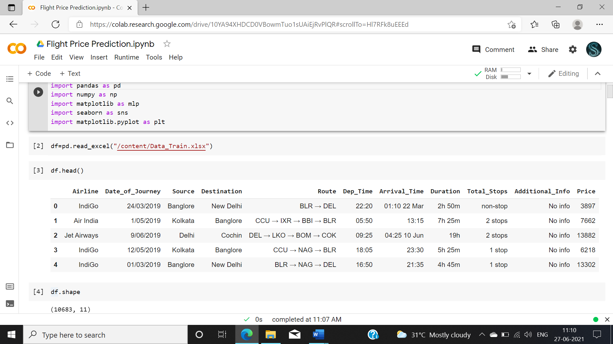

Fig1 – imported the required libraries and imported data set.

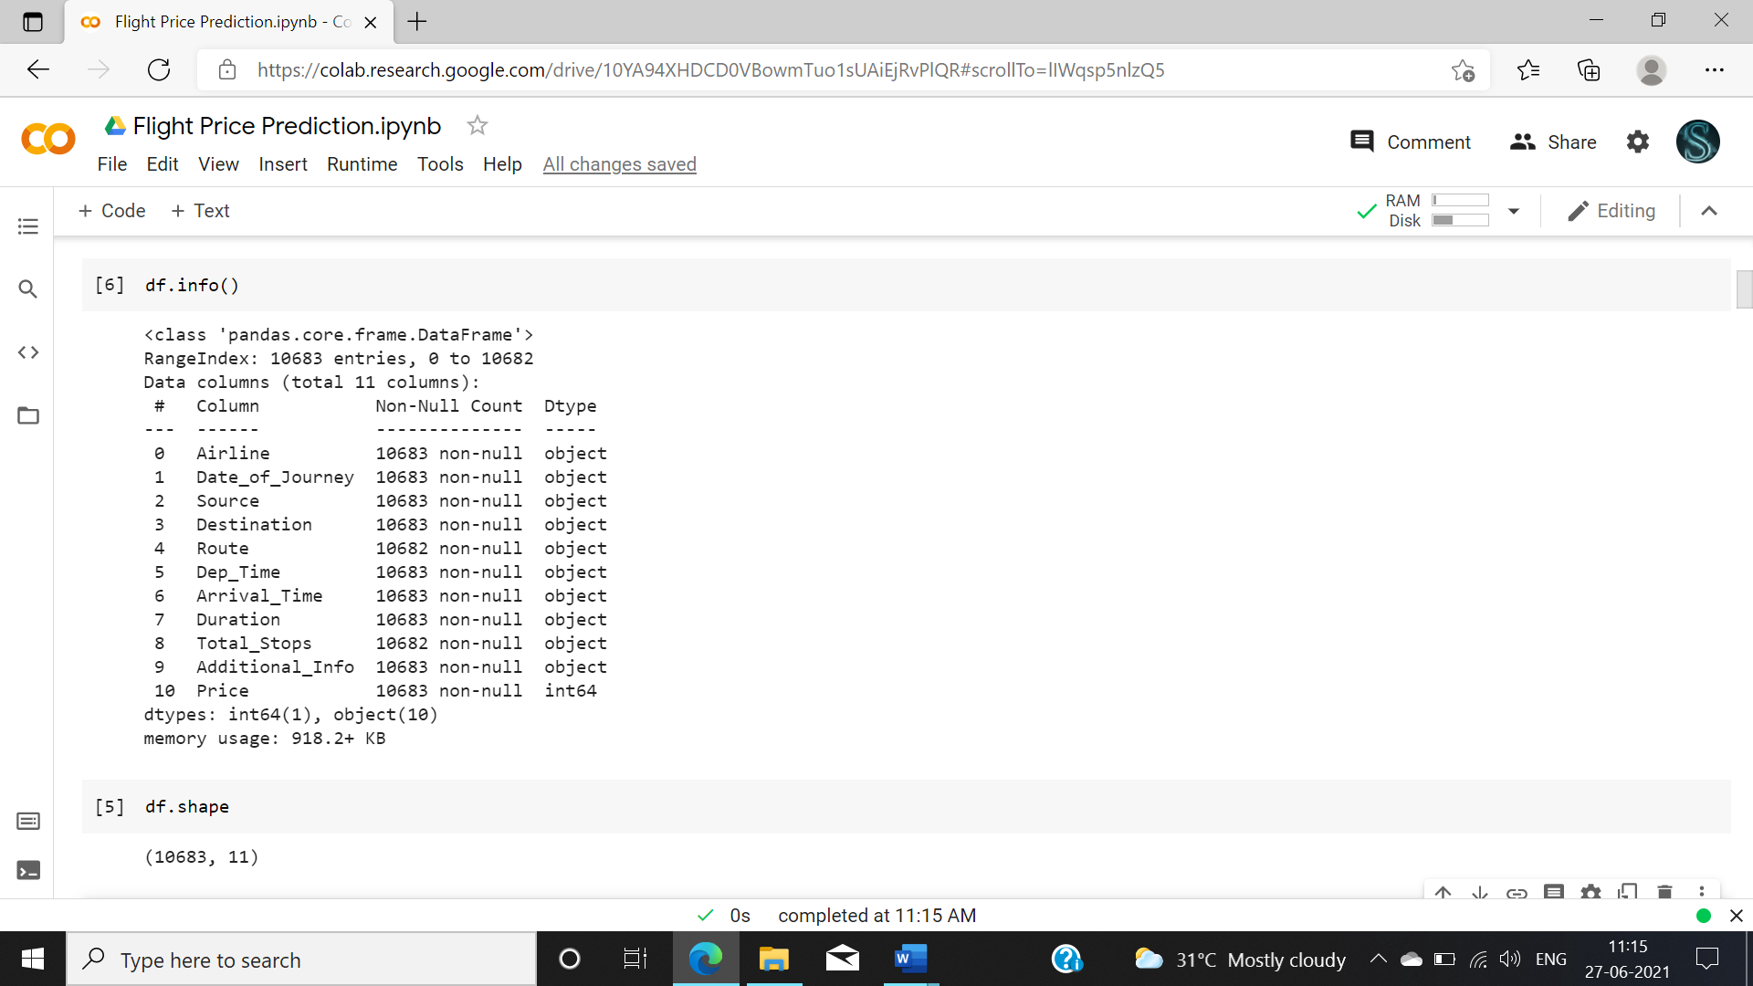

Fig 2 – Information about the attributes in the data set.

**STEP 3: EDA CONCLUDING REMARKS**

First we need to do the pre processing and examine the data need to find the shape of the data and check for any null values present in the data.

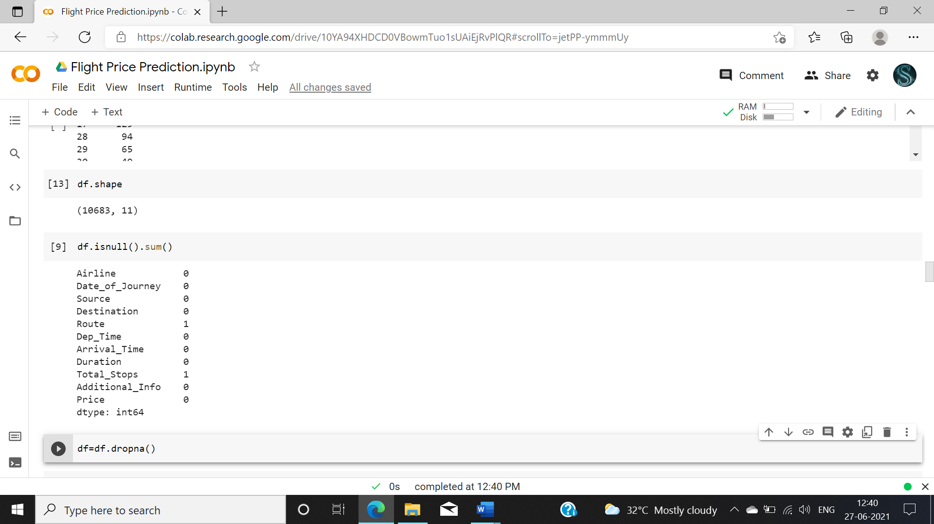

Fig3- Checking shape of the data and removing the null values present in the data.

There is another method to remove null value. If your data had more null values then you need to replace it with the mean, median mode vales. There is a simple thing you need to understand before replacing your null values,

* Replace with **mode** value when your data is categorical.
* Replace with **mean** value if data is numeric and normally distributed.
* Replace with **median** value if data is numeric and not normally distributed.

So Now we need to analyze each attribute individually.

In the attribute Additional_Info have information about meals plan, baggage details etc., but that attribute is having 8345 values with “no data” so we need to remove that attribute.

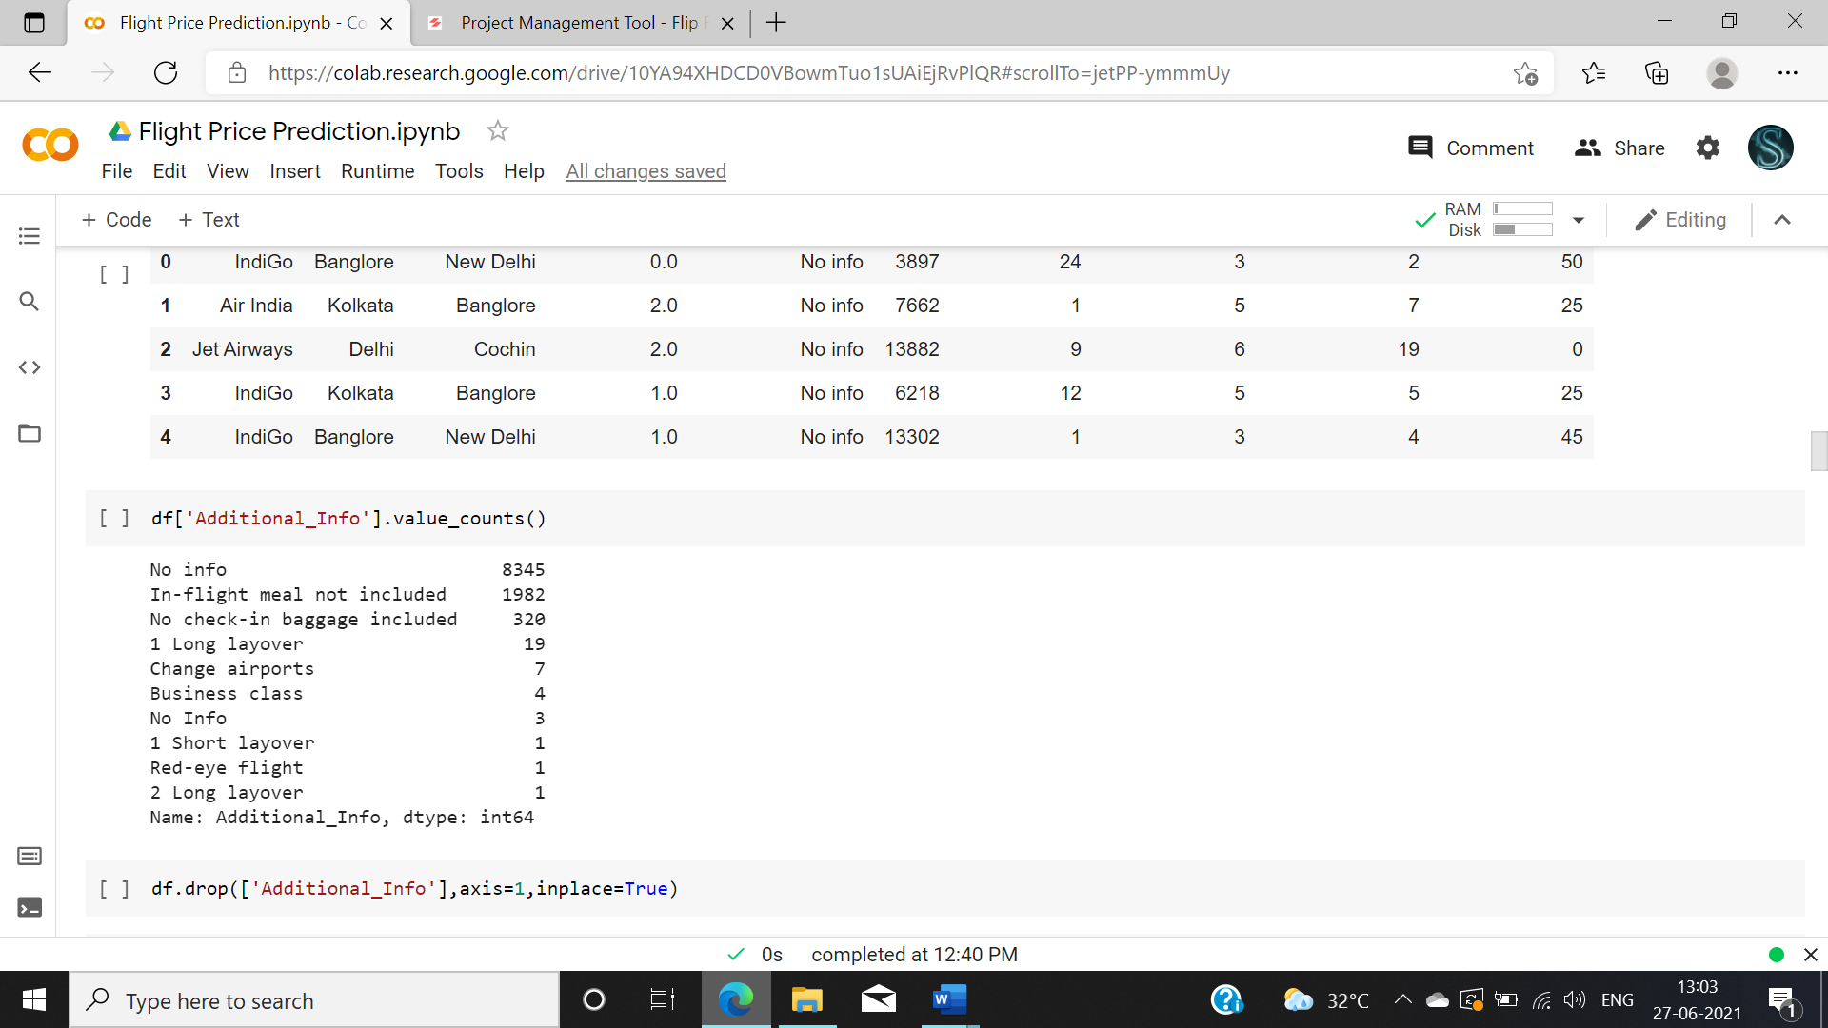

Fig 4: We removed the attribute from the data set.

The attribute “Route” is having the information about the no of change flights. Since we have column “Total Stops” which gives no of flight we don’t need that column so dropping that column.

And we don’t need Arriving time and Departure time since we already have the Duration column.

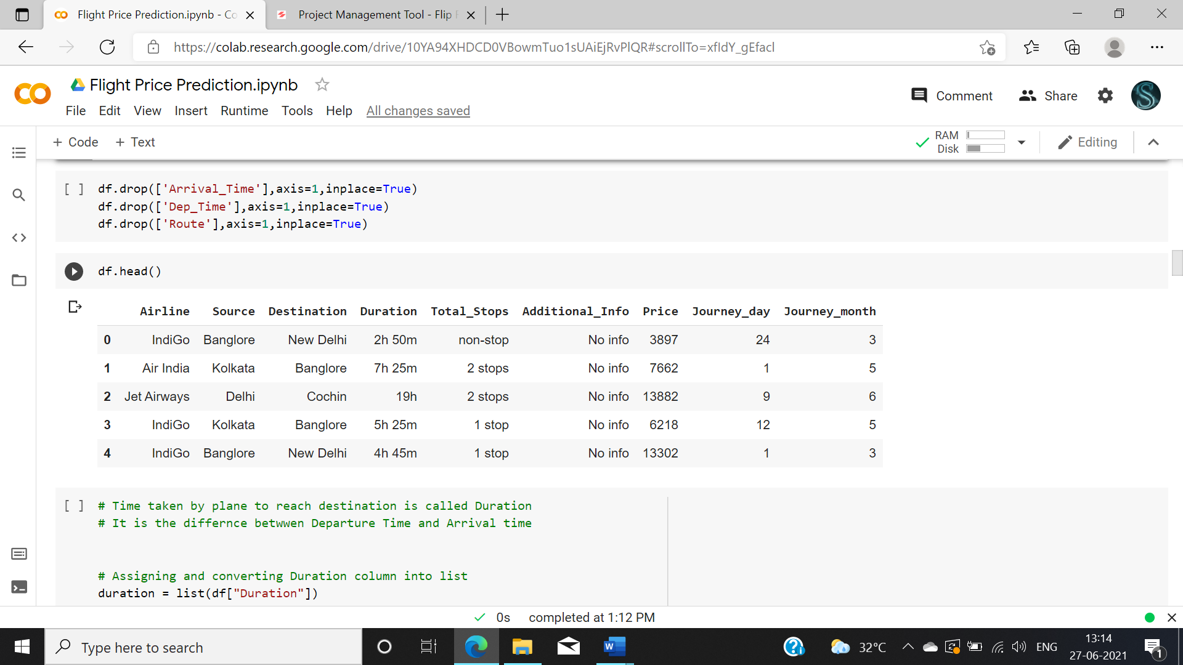

Fig 5: Dropped unwanted column.

After this step you can do visualization technique as per your creativity. **Visuals transform the data into illustrations that help uncover insights**. You can explore data as per your need use multiple plots, different visualization technique. You also need to perform Univariant, Bivariant and multivariant analysis. I will show you few examples how you can use plots.

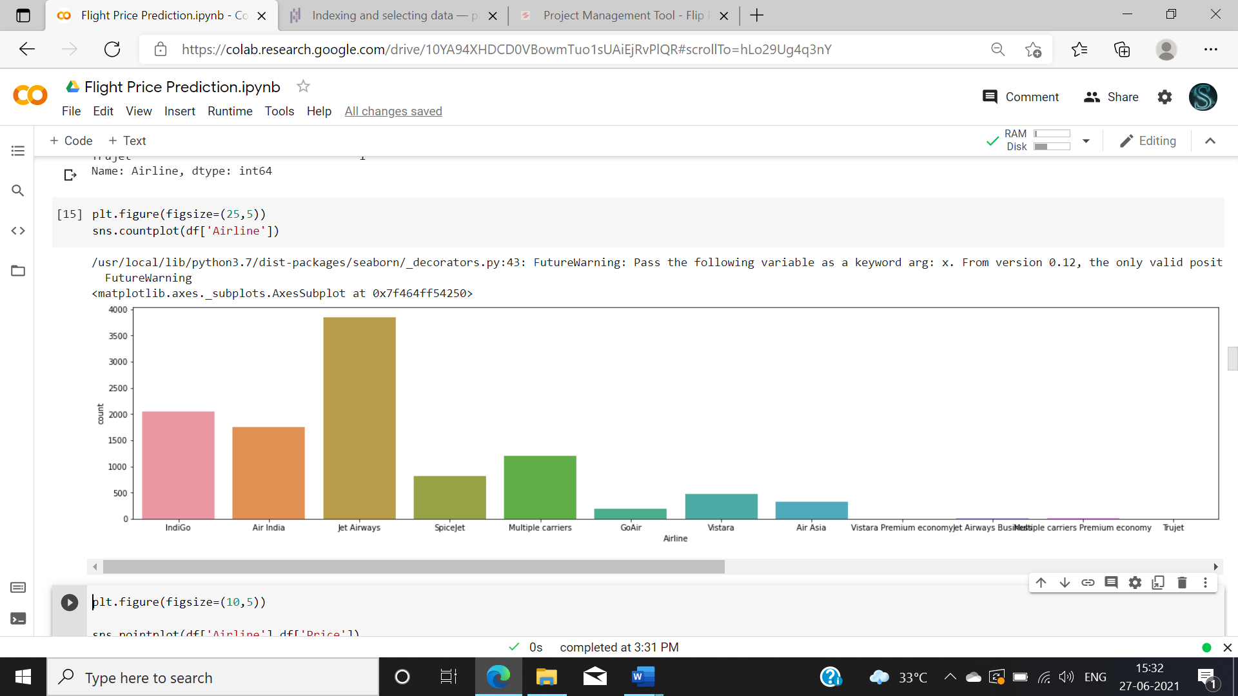

Fig 6: example of visualization

From this plot you can understand about various airline data present in the data.

**STEP 4: PRE-PROCESSING PIPELINE**

Now we need to perform Feature engineering for the multiple attributes present in the data set. It is very important step to be done before analysis because some of the data might be raw which are not applicable for analysis. Now we will do feature engineering for some of the attributes present in the data.

Need to convert date, month, year into data and month in separate columns.

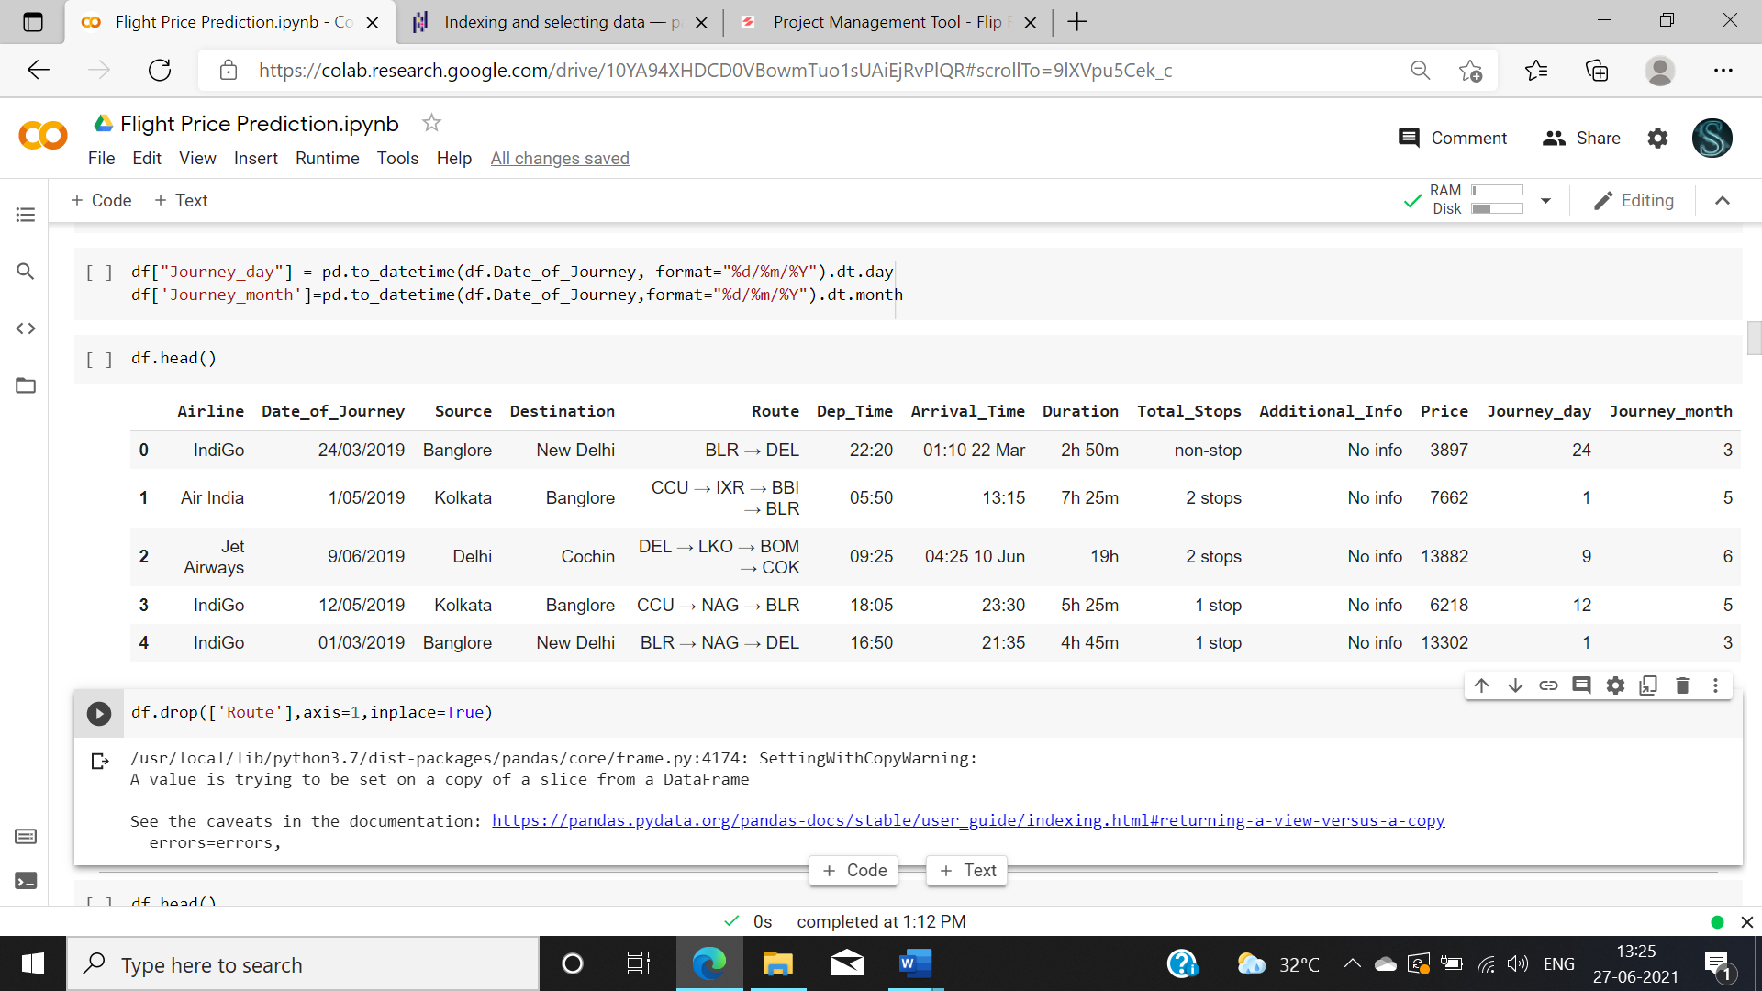

Fig 7: converted date to date and month separately.

Need to convert the Duration column into hours and minute separately.

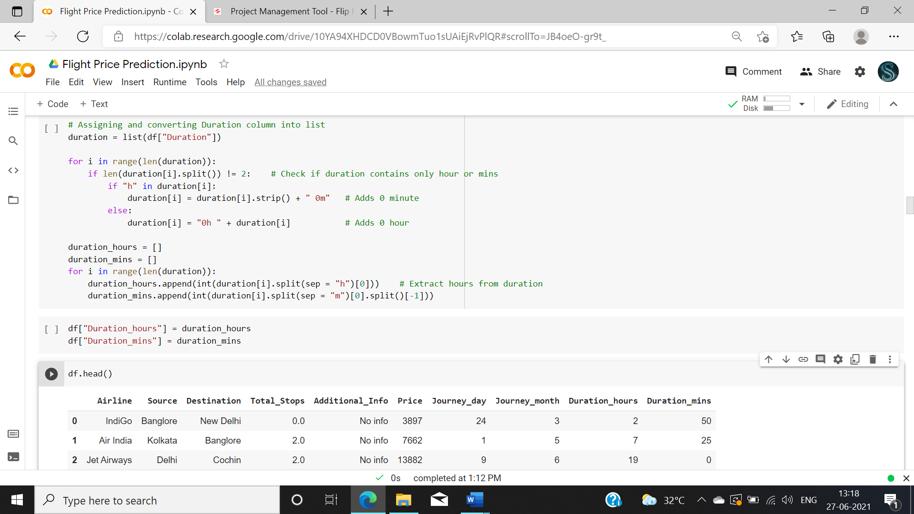

Fig 8: Duration column into hours and minutes.

Converting the Total stops into object to numeric

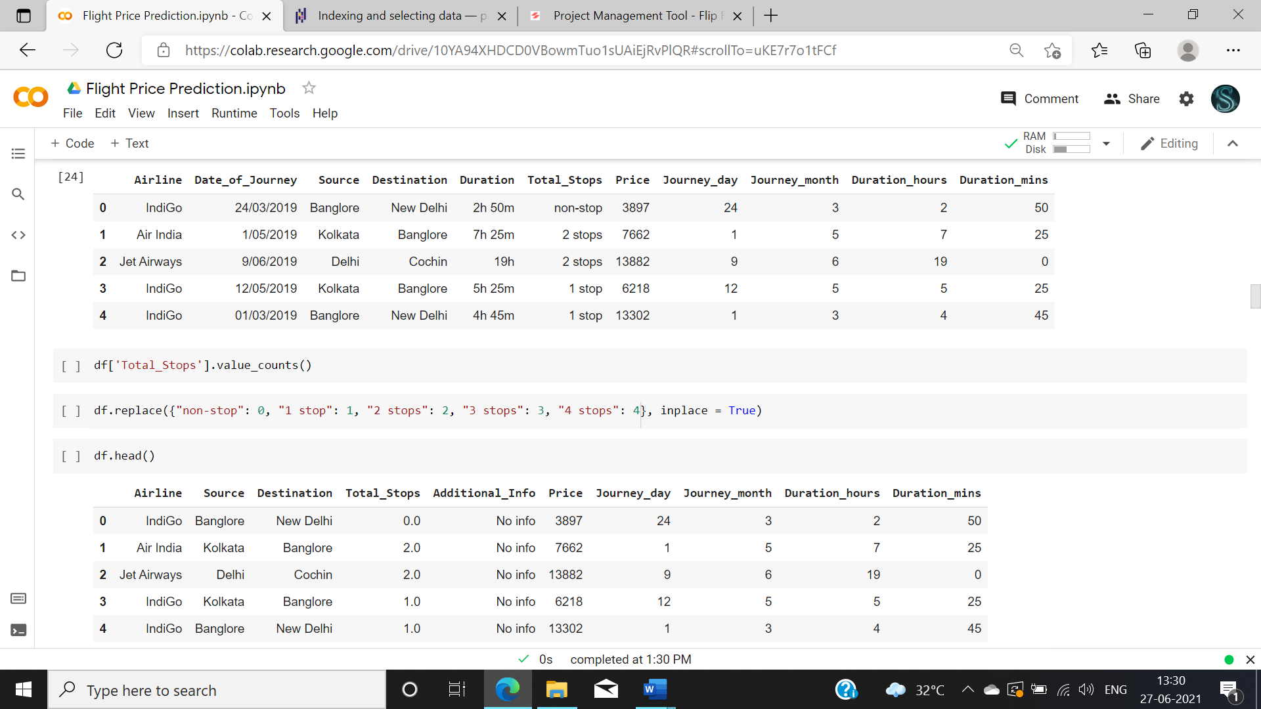

Fig 9: Converted into object to numeric.

We also need to check the skewness of the data before constructing the model. Having outlier might be a reason for skewness. In that case outlier must be removed. You can find outliers in the data by plotting box plot.

Outliers removing tecniques

* IQR
* Z score

Then skewness need to be treated using various techniques like

* square root transformation
* cube root transformation
* Log Transform
* Box-Cox Transform

In our case we don’t have any outlier or skewness

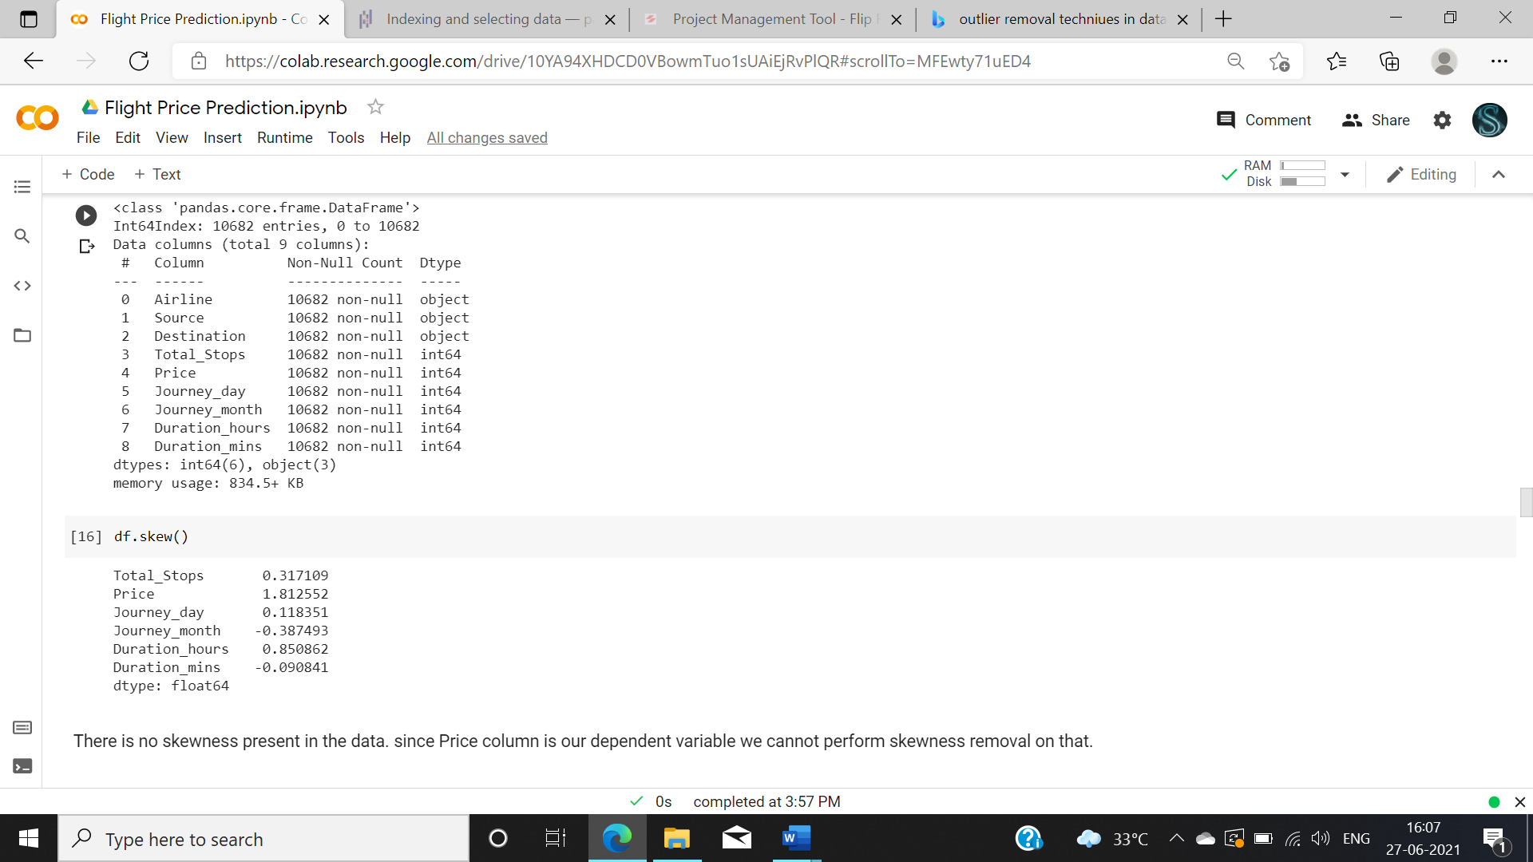

Fig 10 skewness removal

Now after preprocessing we need to perform encoding since we have a few categorical data such as airline, source, destination.

There are two encoding techniques present one is label encoding and other is one hot encoding.

* Label encoding needs to be done only with the labeled data. This label encoding maps the variables with numbers. E.g., Chennai =1, Mumbai =2, Delhi =3.
* One hot encoding creates multiple attributes and uses 0 and 1 to represent the data. We can perform this technique for the our data set.

And we also need to separate the dependent and independent variable. In this case our Y variable is Price.

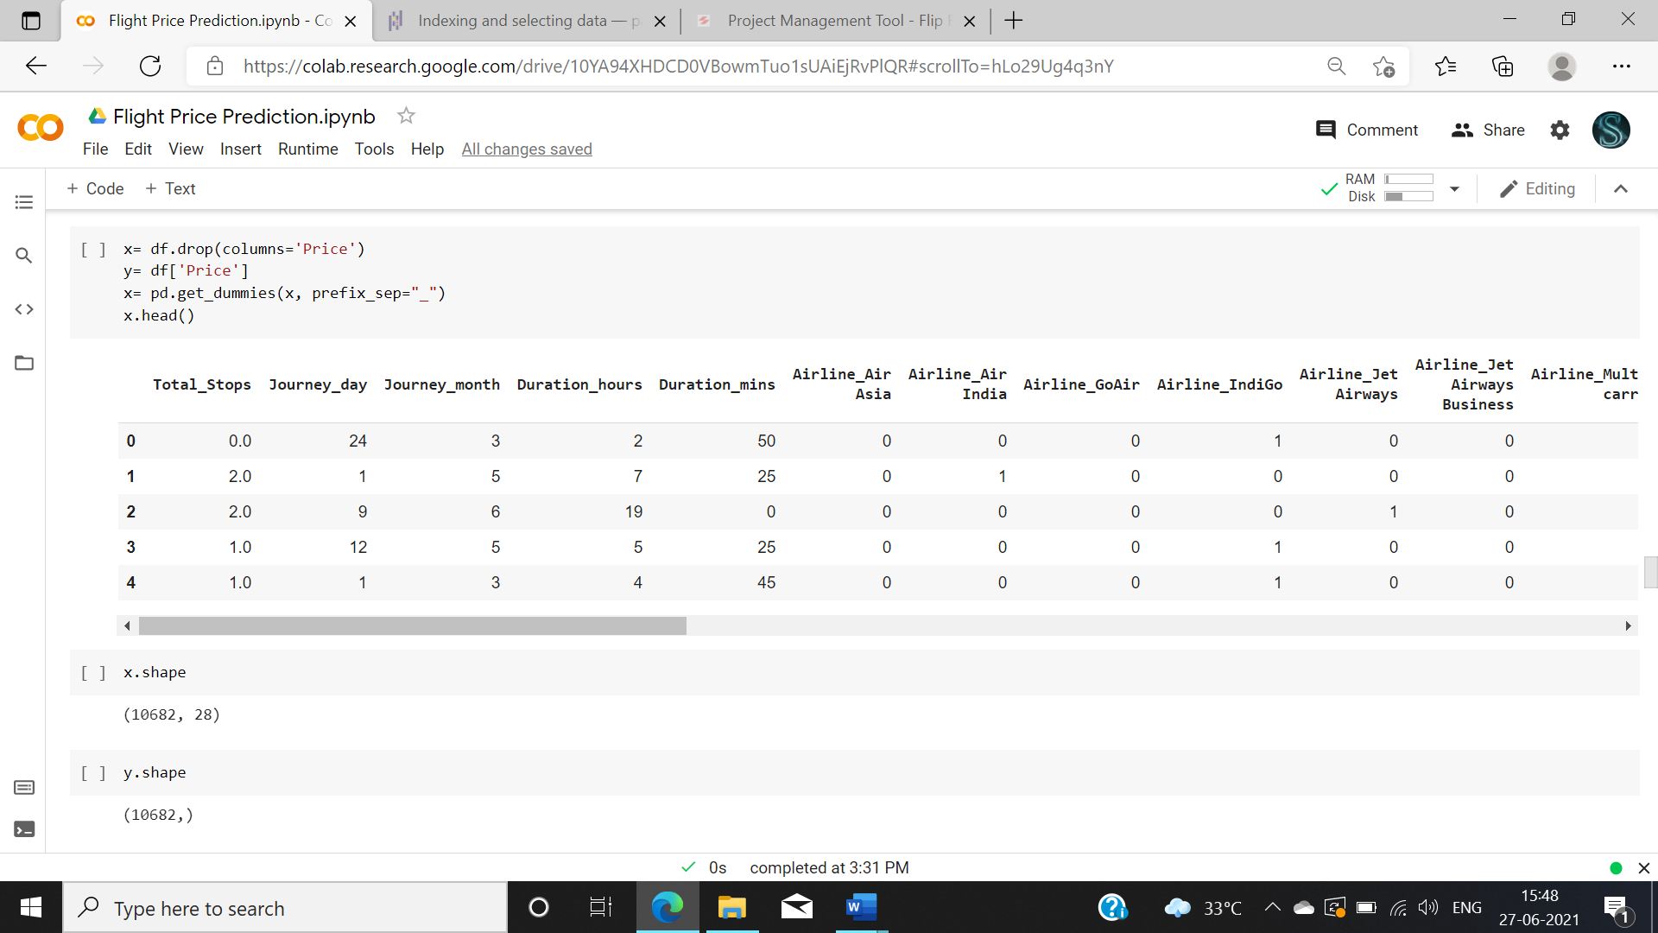

Fig 11: one hot encoding.

We need to split the test and train data before proceeding further.

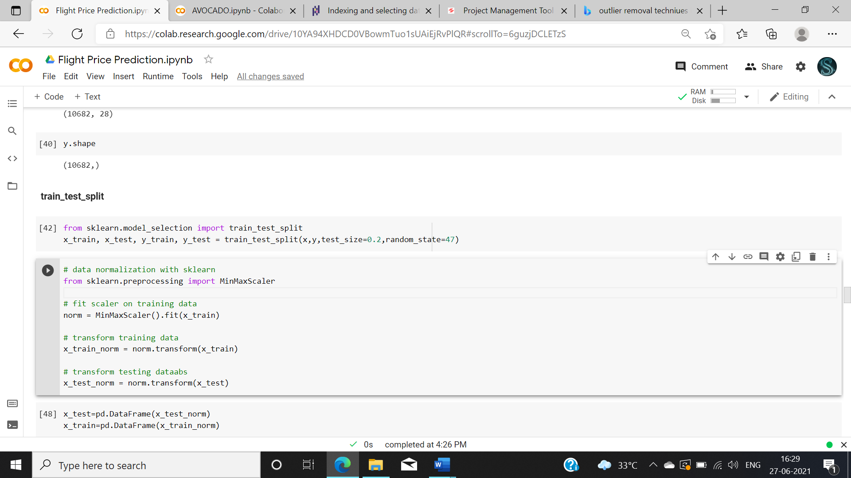

Fig 12 test train split

After encoding we need to perform scaling. Scaling needs to be done because attributes in our data might have a high range. we need to reduce that range in-order to perform efficient model. Here we used min max scaling we can also perform standard scaler to scale the data. After scaling your data will be converted into 0 to 1 format.

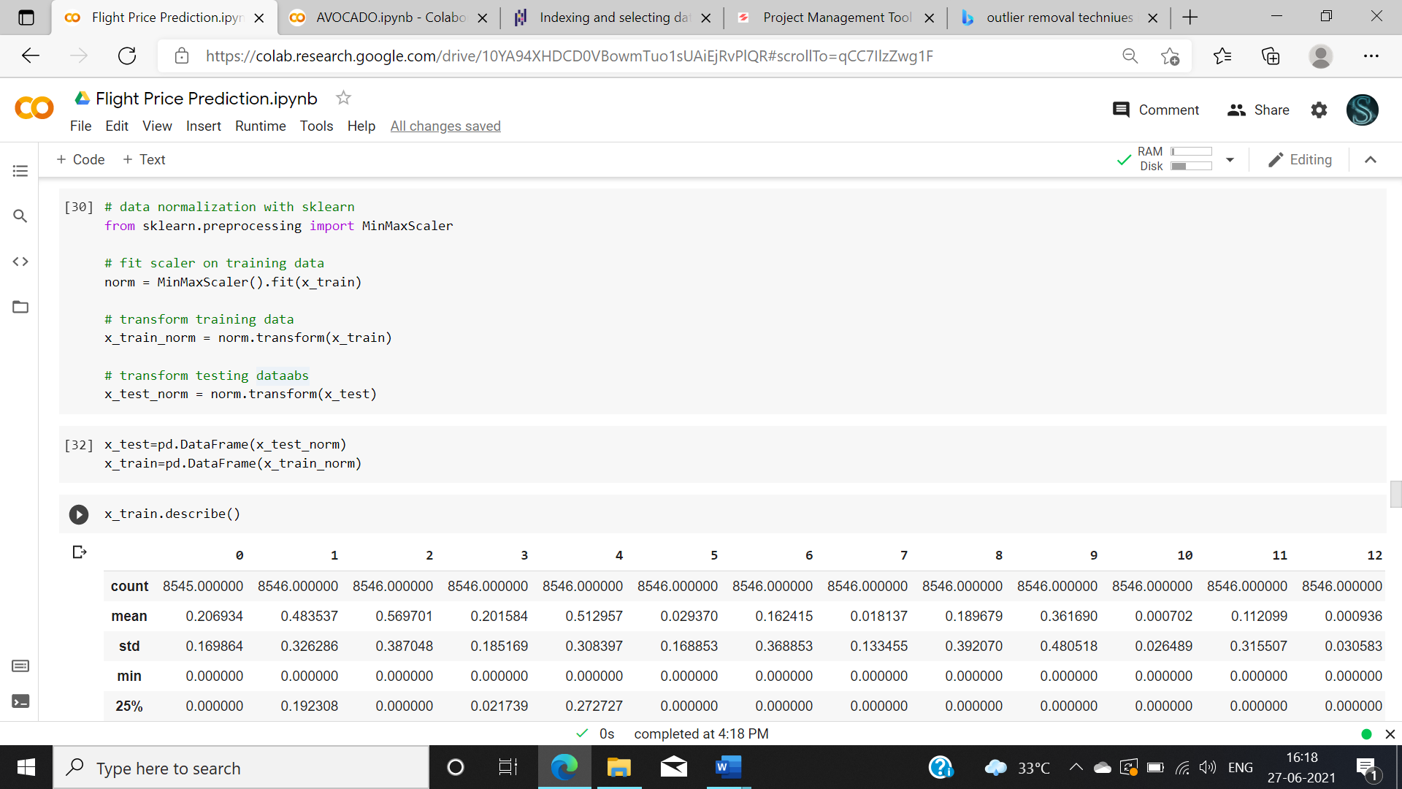

Fig 13: encoding

**Step 5- Building Machine Learning Models**

Now we have came to the most important and sensitive step of the whole analysis part which is constructing and finding best model for our data.

First before constructing the model we need to find the best random state. It helps in increasing the accuracy. Random state is the state where there is a least difference between test and train data score.

I have constructed a basic loop to find the best random state.

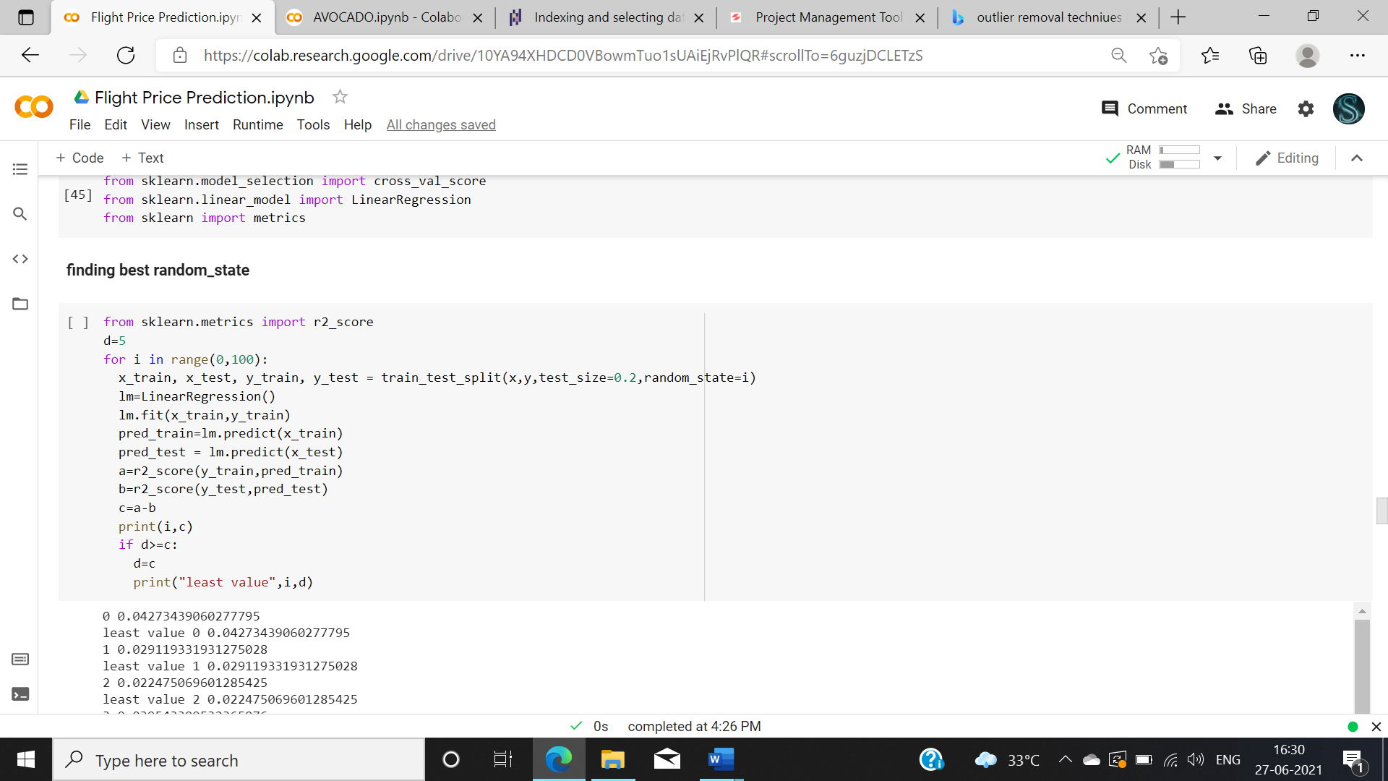

Fig 13: finding best random state.

After performing this model, we found the best random state is 57 in this case.

Now we need to construct various algorithms for this data set. Then using evaluation metrics, we need to finalize some best model for our problem. There are various algorithms available for regression problem we are going to see some of that.

1.LINEAR REGRESSION

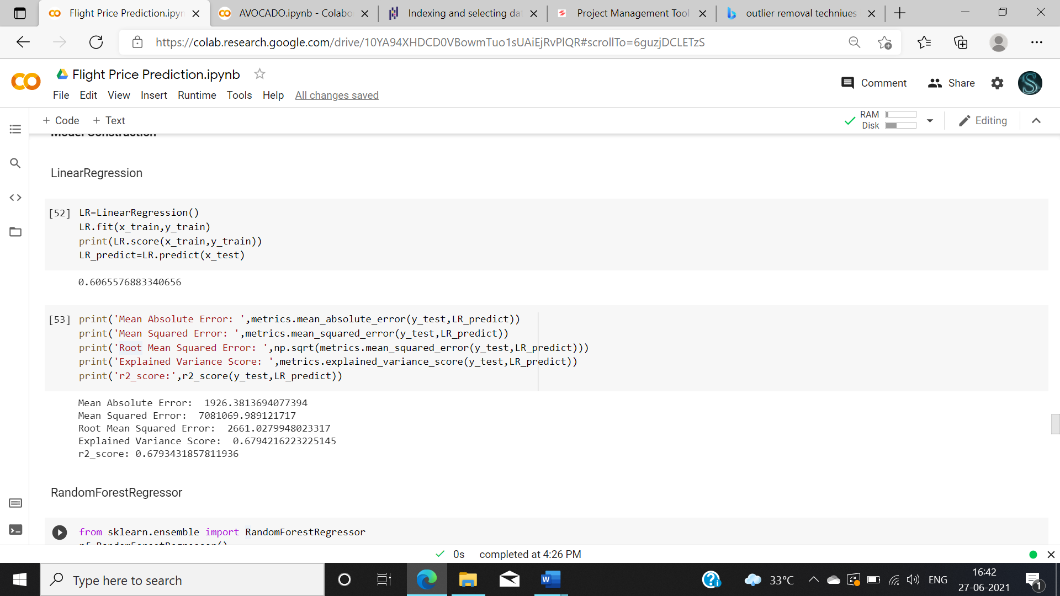

Fig 14: Linear regression

2. RANDOM FOREST REGRESSOR

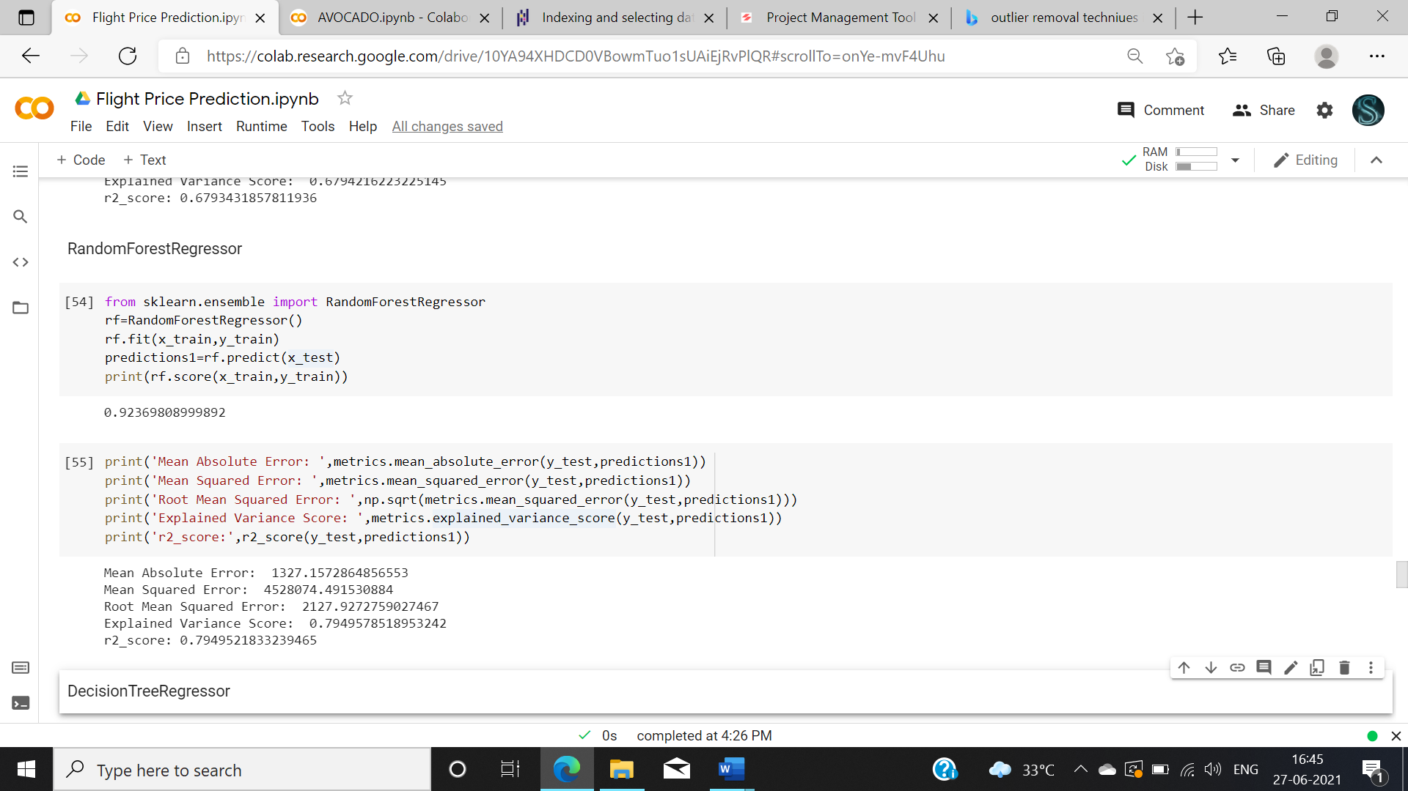

Fig 15: random forest regressor

3. DECISION TREE REGRESSOR

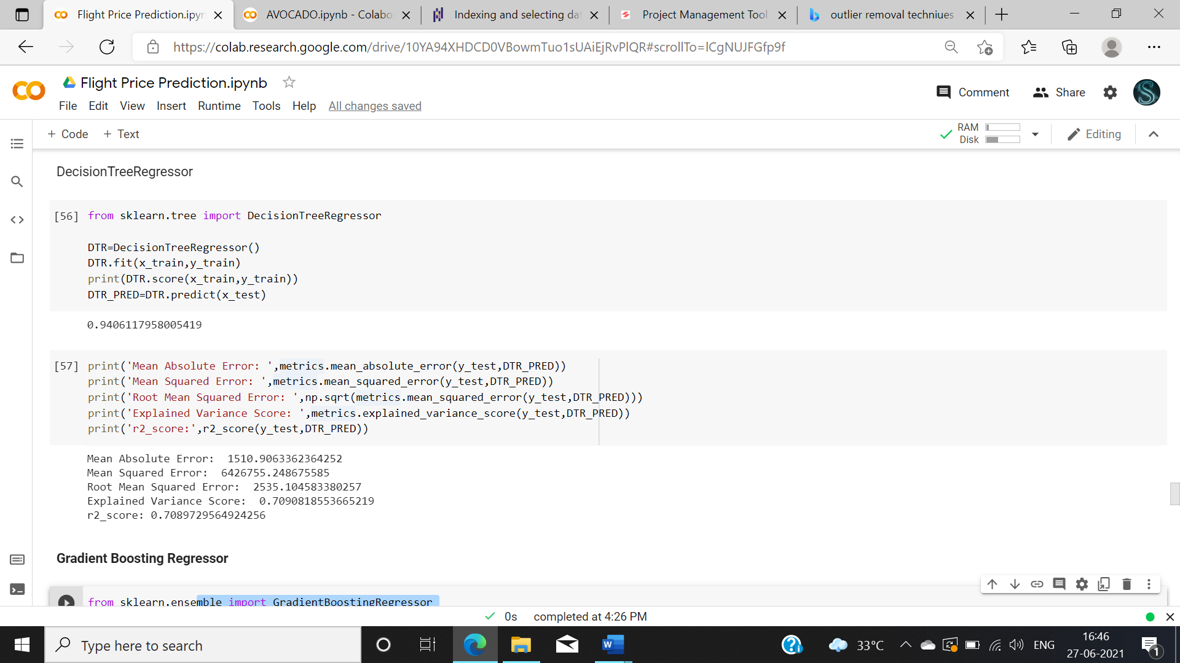

Fig 16: Decision tree regressor

4. GRADIENT BOOSTING REGRESSOR

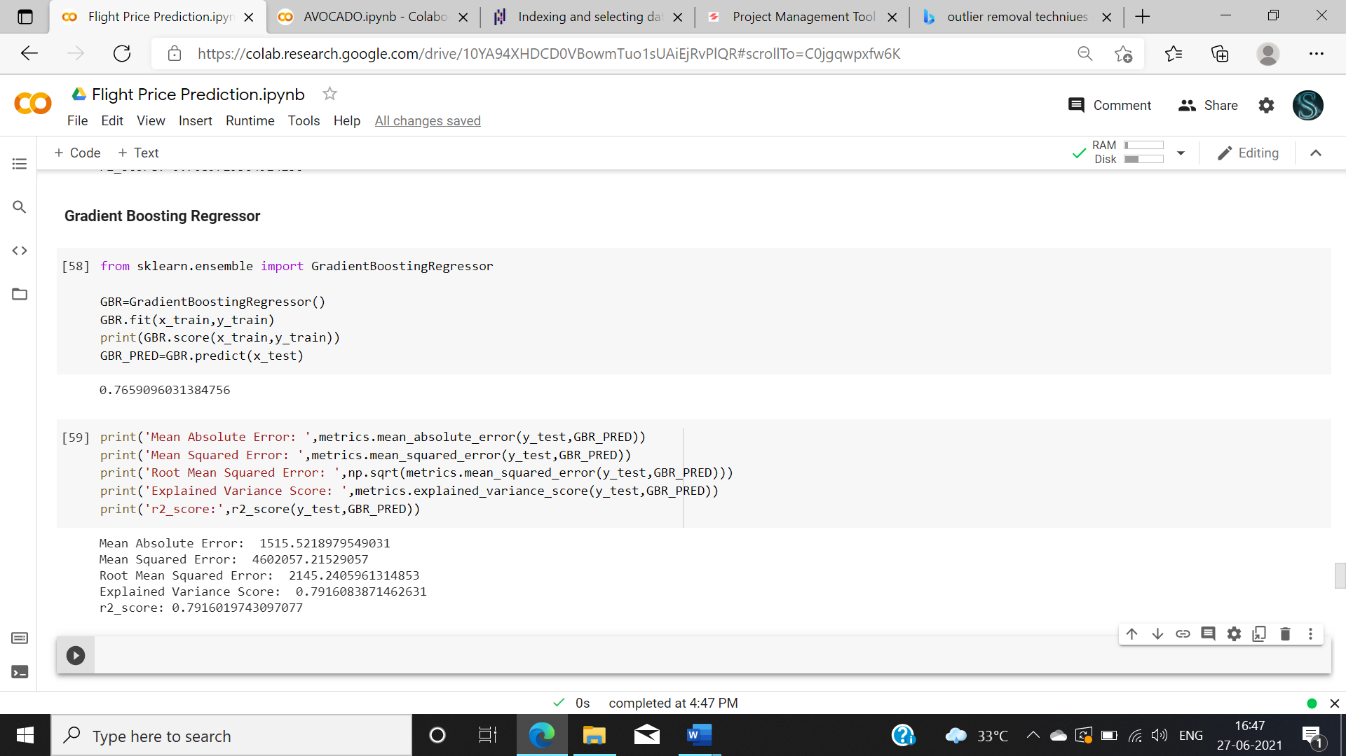

Fig 17: gradient boosting regressor

After constructing all the models, we found that Random forest regressor having high r2 score so moving on with hyper parameter tuning with that model.

Hyper parameter tuning tends to increase the accuracy of the model.

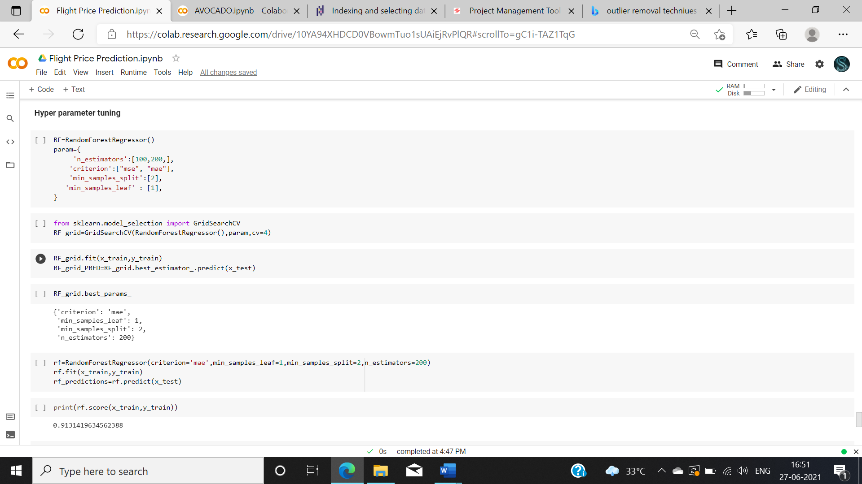

Fig 18 Hyper parameter tuning.

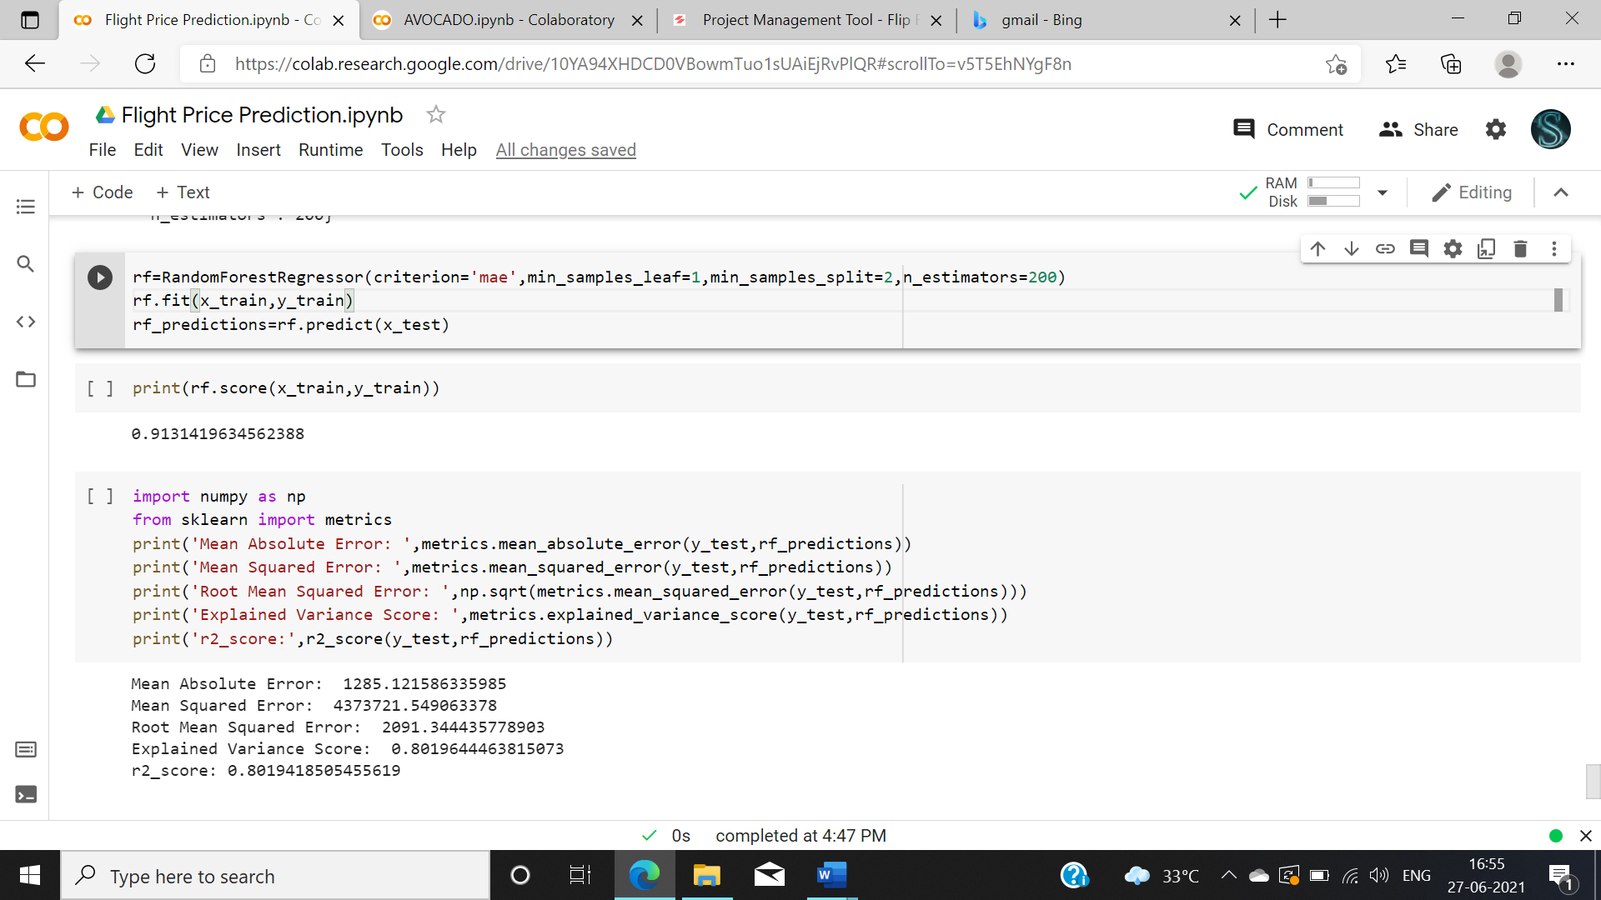

Fig 19 hyper parameter tuning results.

After performing hyper parameter tuning r2 score increased from 79% to 80%

**6.      CONCLUDING REMARKS**

By the end of this project, we have predicted the price of the flight ticket

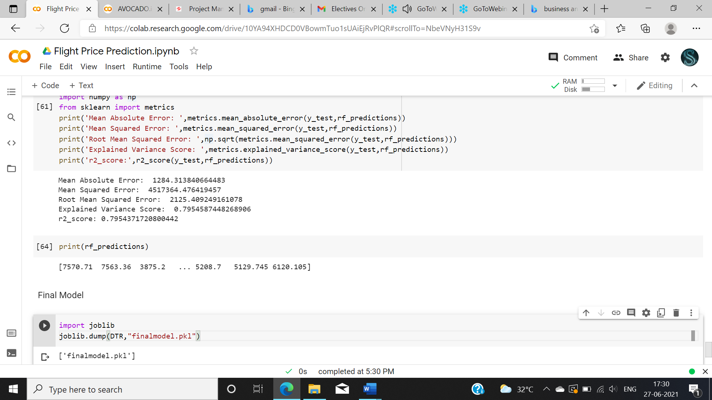

Fig 20: Predicted price

By performing this project, we got a good knowledge about how to perform an analysis and how important preprocessing a data. How to construct Machine learning models to predict the data. And how to choose the best model for specific data.

By performing uni-variant, bi-variant and multivariant analysis we can see the correlation between the data. We can make assumptions on the data and perform model.

**EXAMPLE 2**

HR Analytics prediction database

We earlier saw an example of regression problem now we see how to solve a classification problem. In this example we are going to see about constructing a machine learning model for “HR Analytics prediction database”. This machine learning project we will be doing on python. We will perform the analysis step by step and predict whether the new candidate applied for this company will be selected or not.

**STEP 1:  PROBLEM DEFINITION**

When a large-scale software companies are considered, they will get a lot of applications for the job interview. Since the cant interview all the candidates since it takes a a lot of time and manpower consumption, they decided to build a model which predicts their candidates who are eligible for their job role and predict the candidates who will be most eligible for their job role.

**STEP 2: DATA ANALYSIS**

In this data set we are provided with various candidate’s data who attended interview earlier with their results. In that database they given all there details about their education, previous job, interests etc., You can find the data set in GitHub. First, we need to import all the libraries needed then we need to import the data set.

After that we need to find whether the problem is Classification or regression problem. If your predictor variable is categorical then it is a classification problem. If the predictor variable is continuous then it is a regression problem. Our problem is a classification since our predictor variable is categorical.

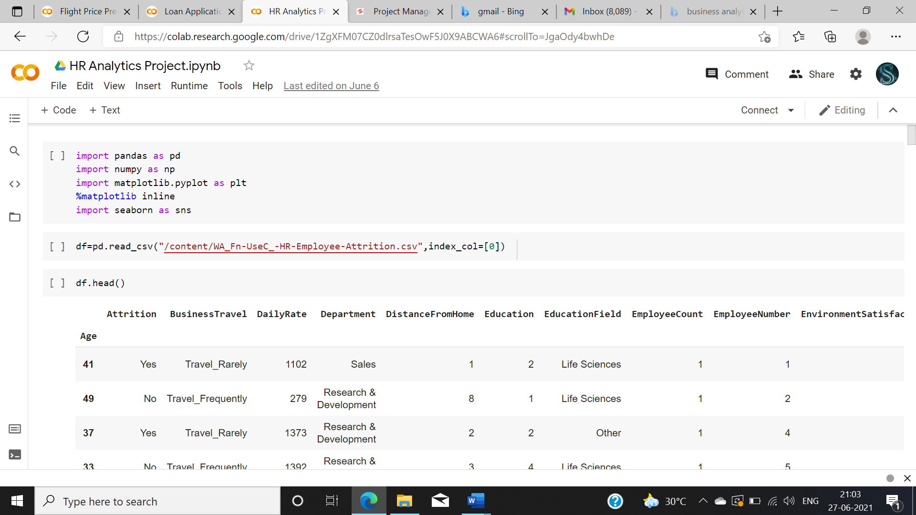

Fig1 – imported the required libraries and imported data set.

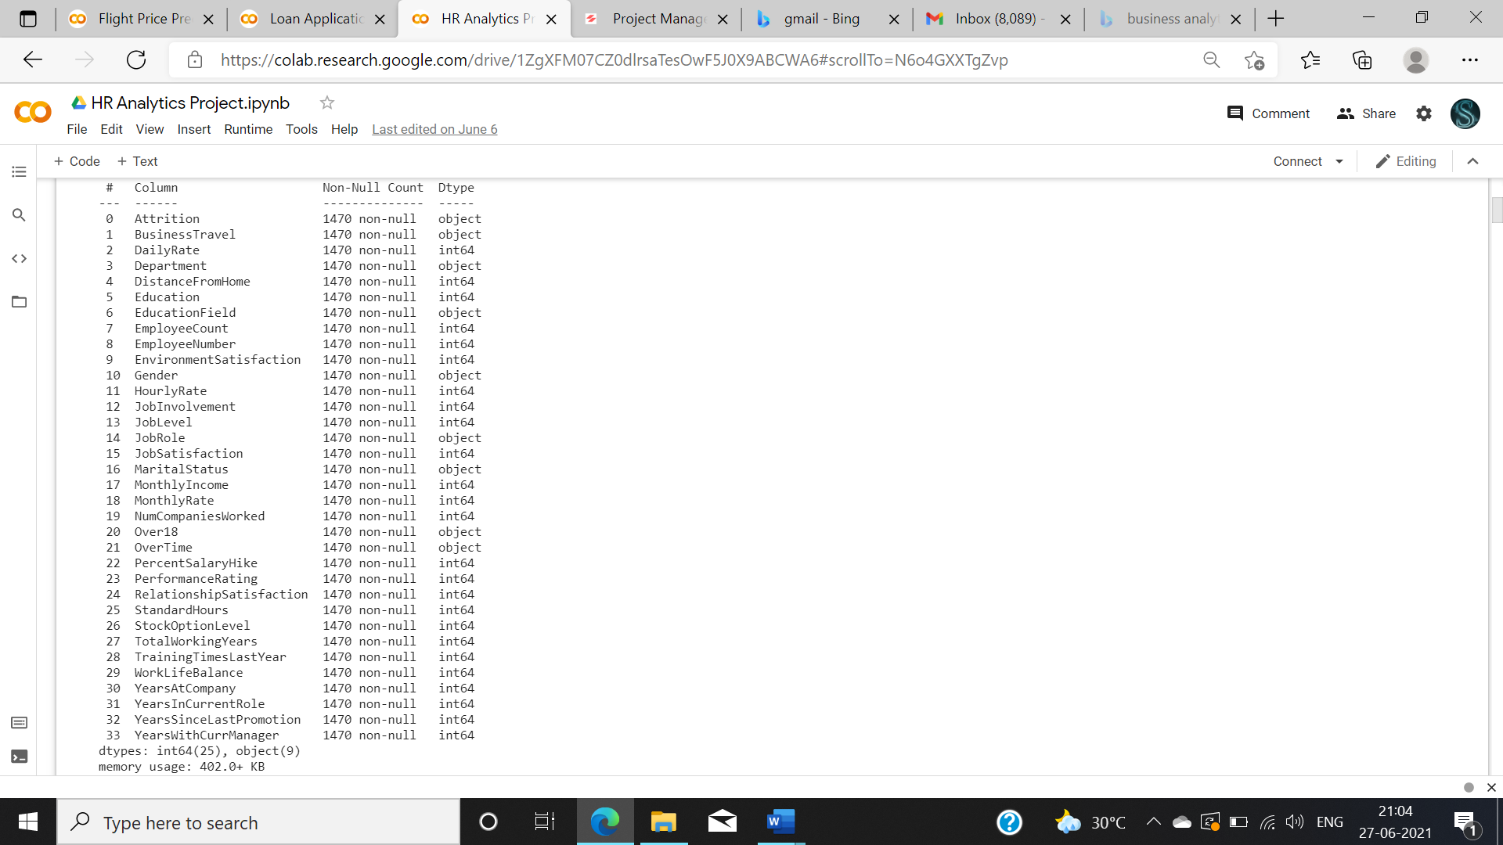

Fig 2 – Information about the attributes in the data set.

**STEP 3: EDA CONCLUDING REMARKS**

First we need to do the preprocessing and examine the data need to find the shape of the data and check for any null values present in the data.

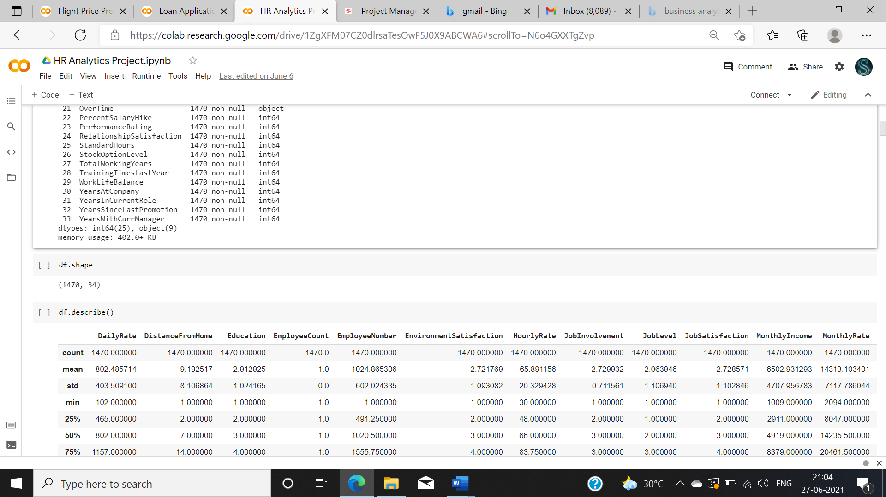

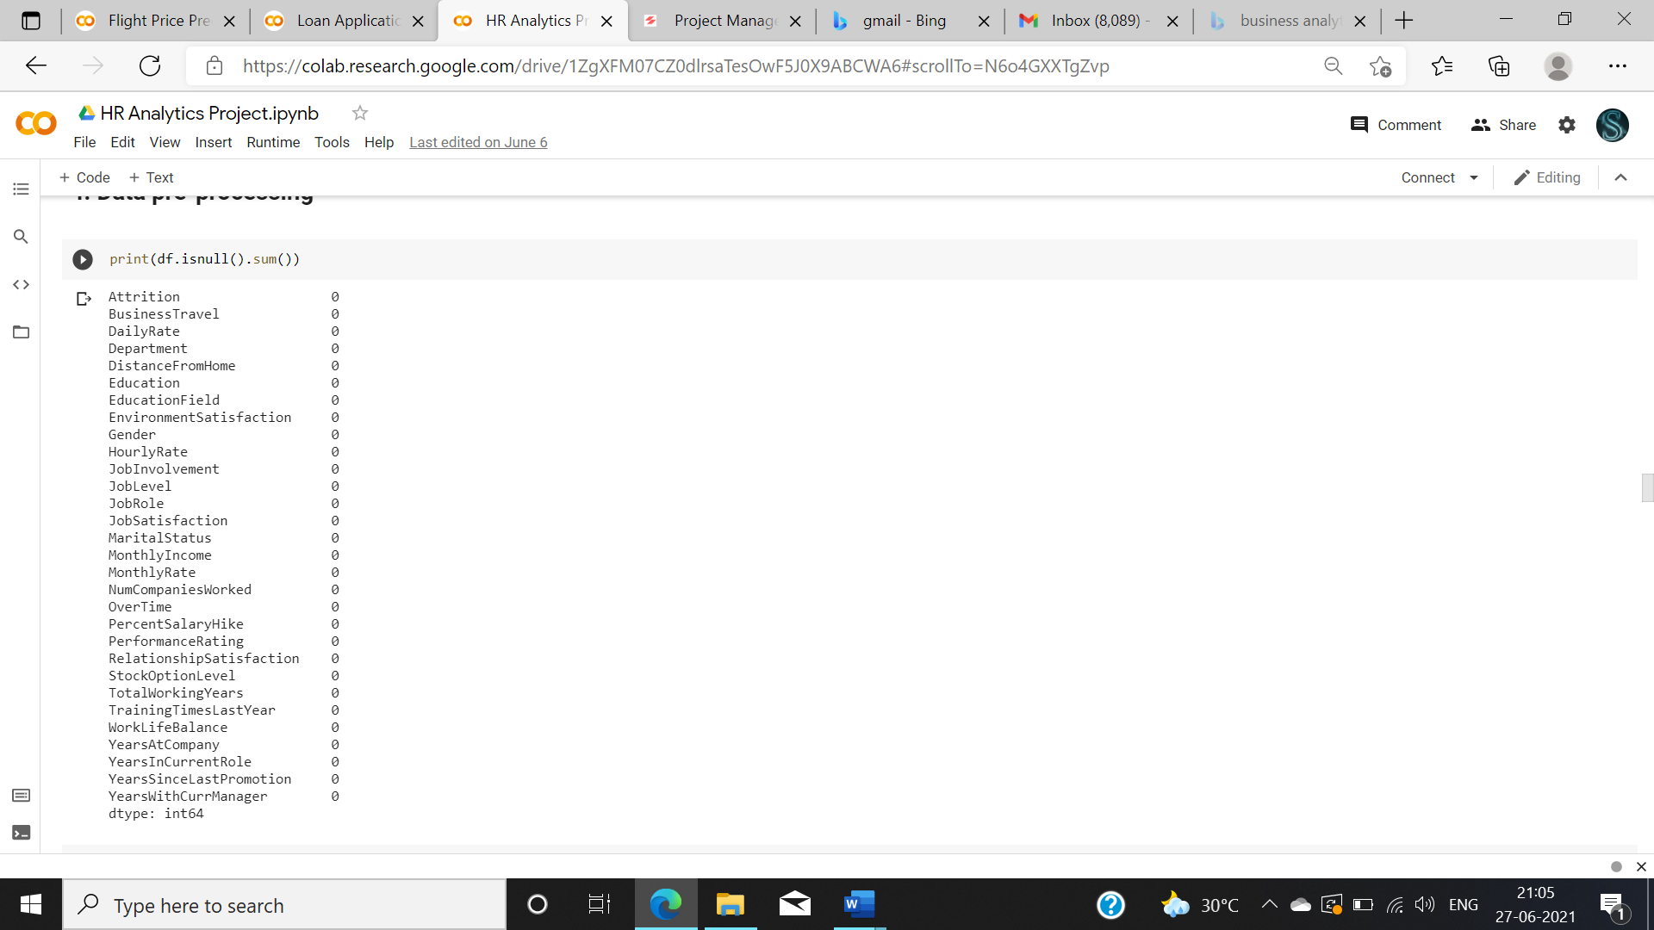

Fig3- Checking shape of the data and removing the null values present in the data.

There is no null values present in the data you can drop the null values if there are few or there is another method to remove null value. If your data had more null values then you need to replace it with the mean, median mode vales. There is a simple thing you need to understand before replacing your null values,

* Replace with **mode** value when your data is categorical.
* Replace with **mean** value if data is numeric and normally distributed.
* Replace with **median** value if data is numeric and not normally distributed.

So Now we need to analyze each attribute individual

Since most of our data is numeric we can analyze all the data at once like

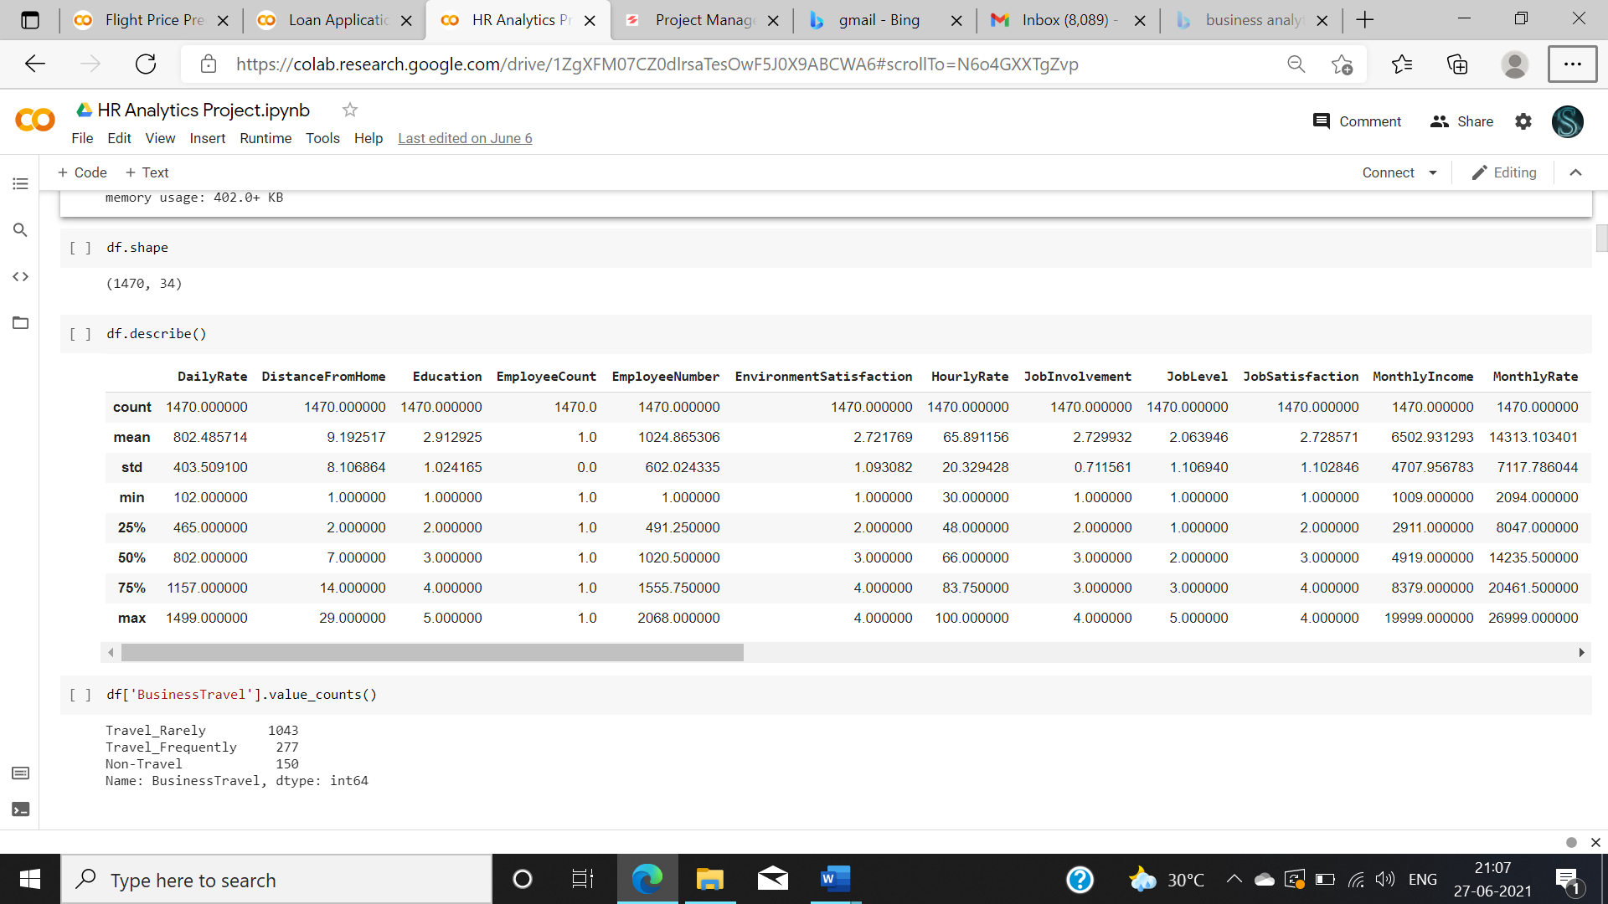

Fig 4: analyzing all the data.

After this step you can do visualization technique as per your creativity. **Visuals transform the data into illustrations that help uncover insights**. You can explore data as per your need use multiple plots, different visualization technique. You also need to perform Univariant, Bivariant and multivariant analysis. Since I cant able to show all the plots I have included some for reset of the plots you can visit at my GitHub link is provided at the end of the blog.

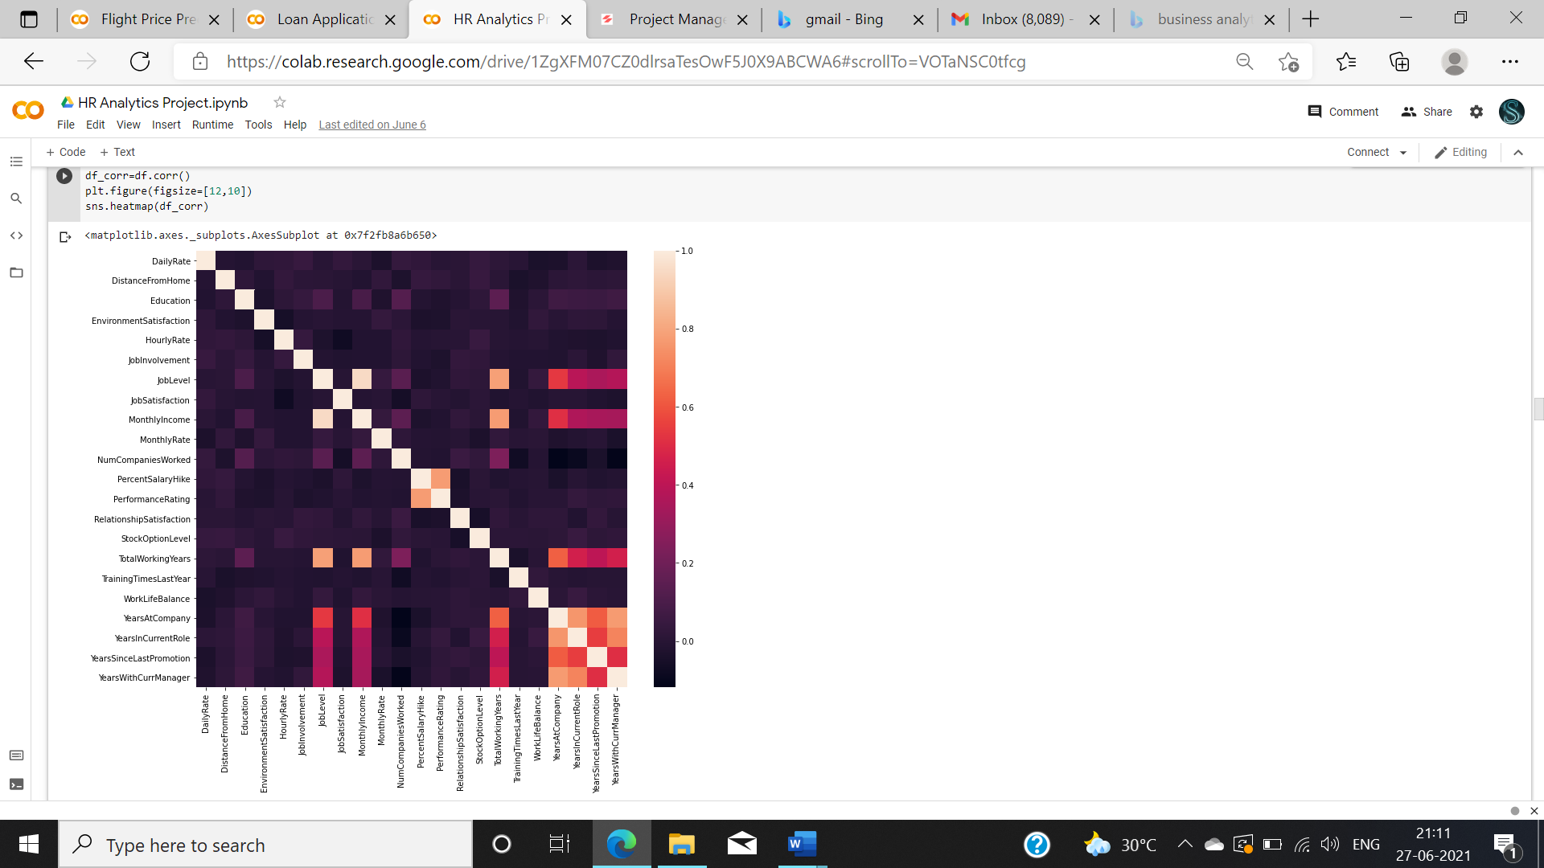

Fig 6: example of visualization

From this plot you can understand about the correlation between each attributes.

**STEP 4: PRE-PROCESSING PIPELINE**

Now we need to perform Feature engineering for the multiple attributes present in the data set. It is very important step to be done before analysis because some of the data might be raw which are not applicable for analysis. Now we will do feature engineering for some of the attributes present in the data.

Since employee number is not important, we are removing that column from the dataset

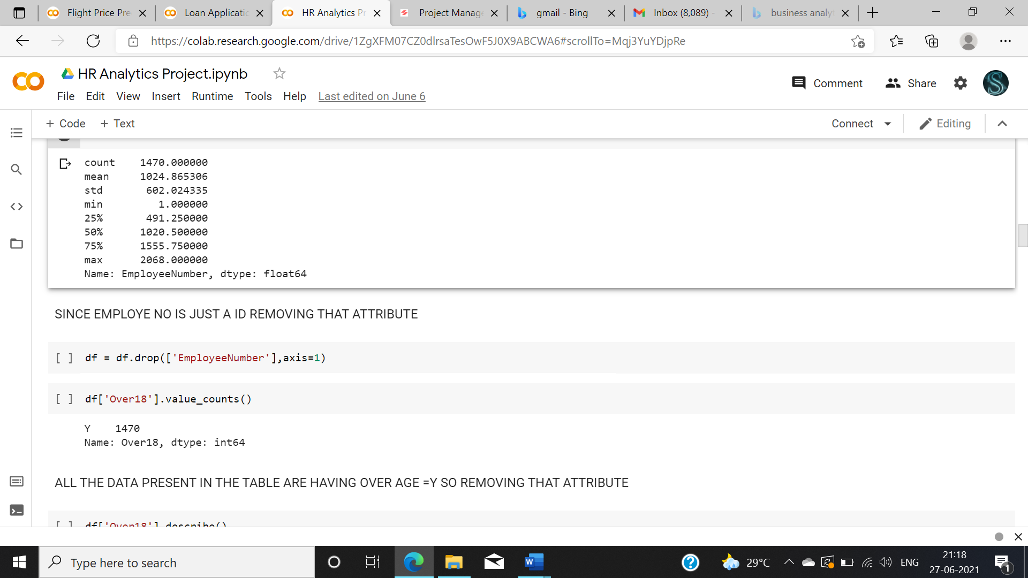

Fig 7: dropping un-wanted columns.

Since all the values in the “over 18” column is yes, “employee count” is 1 and “Standard hours “= 80 so removing the all those attributes.

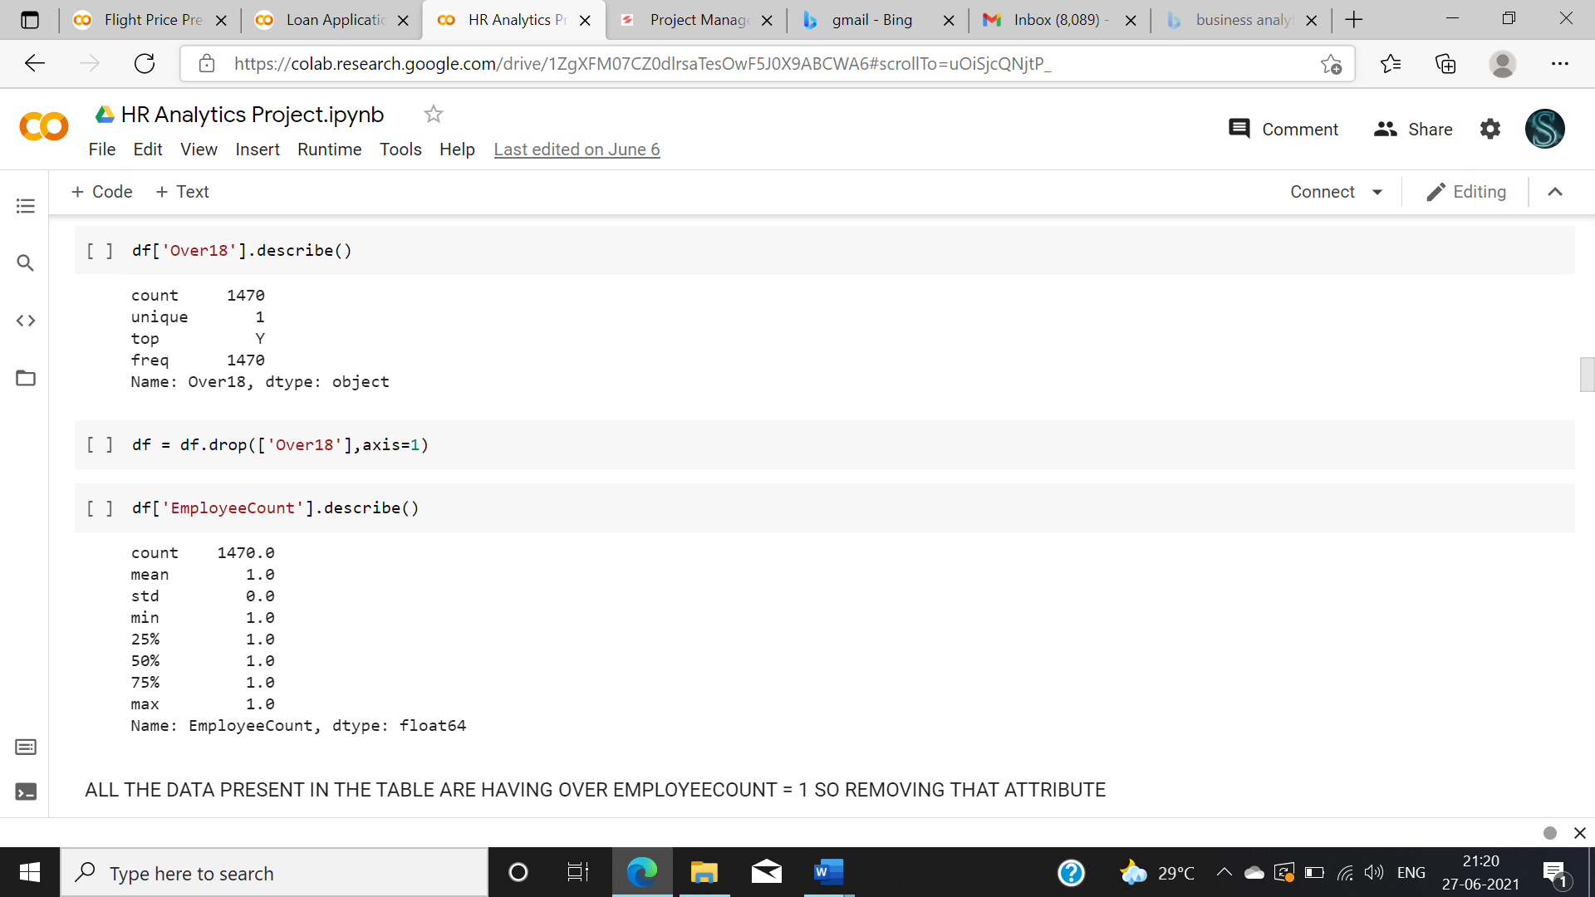

Fig 8: Removing unwanted attributes

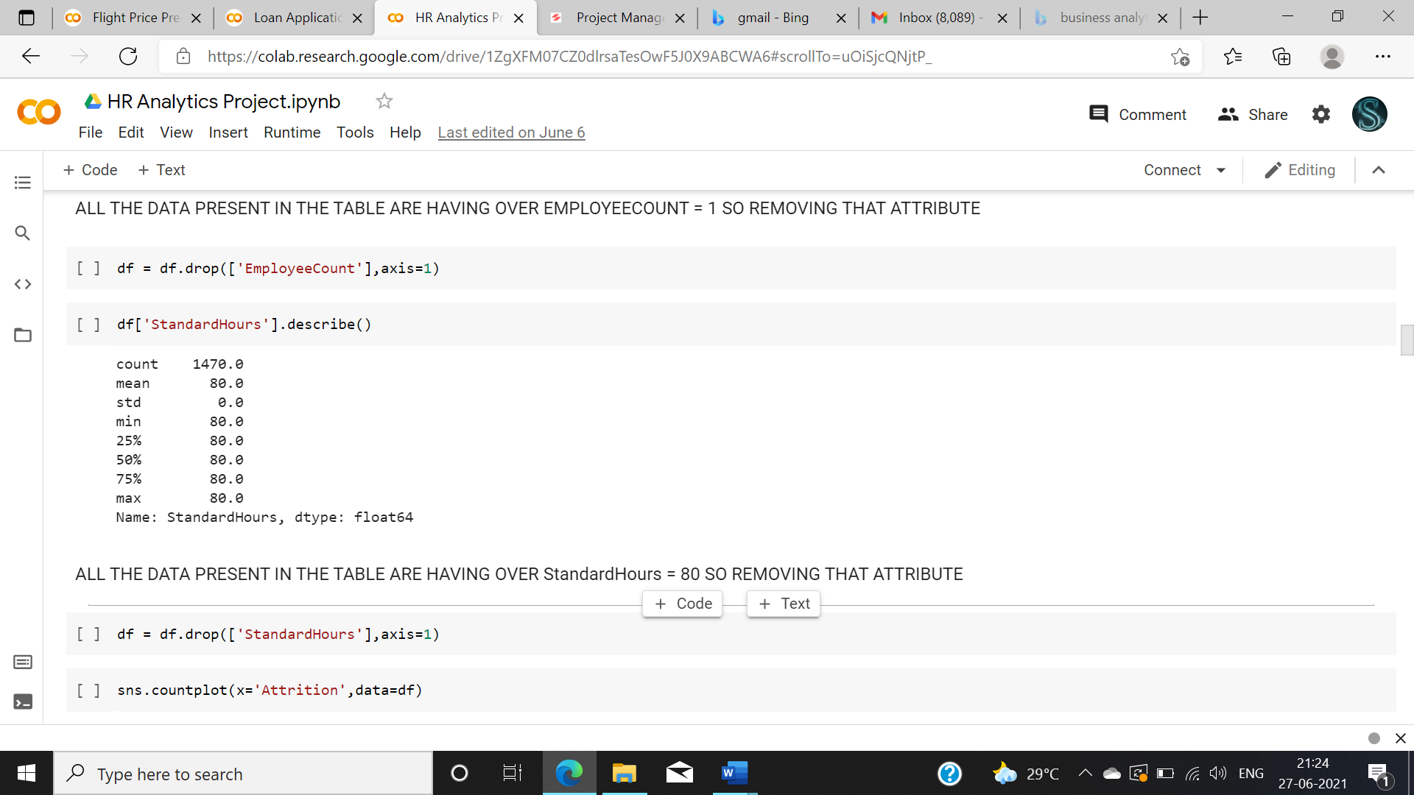

Fig 9 : Removing unwanted attributes

We also need to check the skewness of the data before constructing the model. Having outlier might be a reason for skewness. In that case outlier must be removed. You can find outliers in the data by plotting box plot.

Outliers removing techniques

* IQR
* Z score

Then skewness need to be treated using various techniques like

* square root transformation
* cube root transformation
* Log Transform
* Box-Cox Transform

In our case we since the data is very small if we perform outlier removal the data loss will be high so not preforming skewness removal or outlier removal technique.

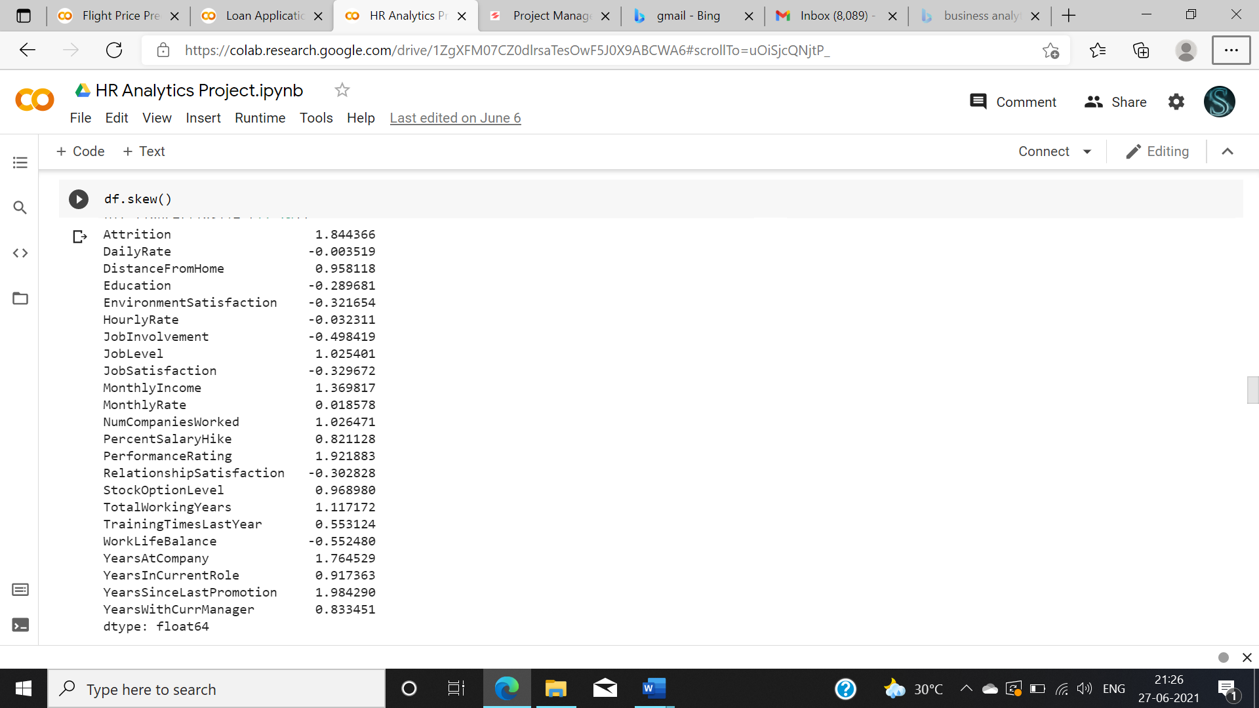

Fig 10 skewness removal

Now after preprocessing we need to perform encoding since we have a few categorical data such as department, education etc.,.

There are two encoding techniques present one is label encoding and other is one hot encoding.

* Label encoding needs to be done only with the labeled data. This label encoding maps the variables with numbers. E.g., Chennai =1, Mumbai =2, Delhi =3.
* One hot encoding creates multiple attributes and uses 0 and 1 to represent the data. We can perform this technique for the our data set.

And we also need to separate the dependent and independent variable. In this case our Y variable is Attrition.

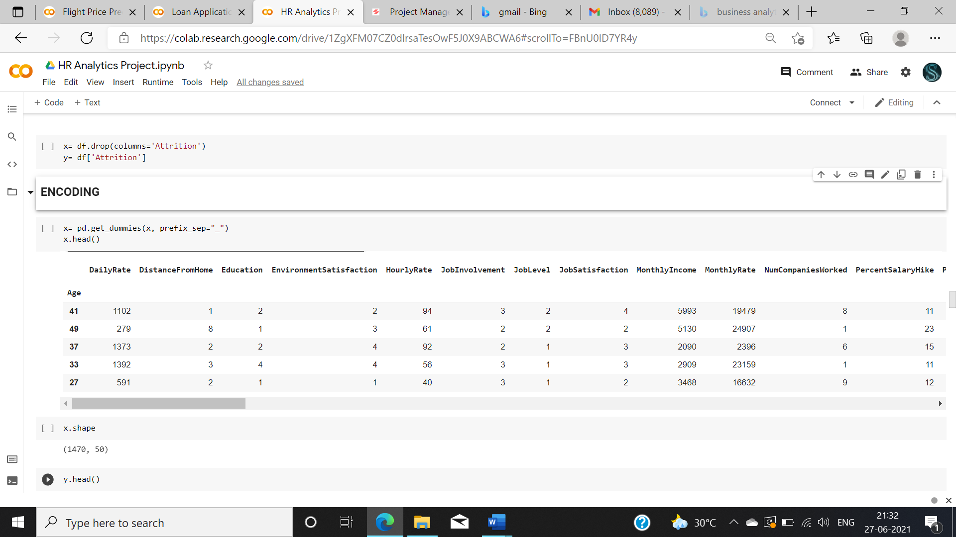

Fig 11: one hot encoding.

We need to split the test and train data before proceeding further.



Fig 12 test train split

Another important preprocessing step is there which we have not seen in the previous example which is treating Data Imbalance which means sometimes data which we are provided with might not be balanced eg., in this case we have data about people got selected and rejected. Since the data will be in the form of most people got rejected and only few got selected our model will be imbalance and predict only the rejected people and fail to predict the selected people. So there is technique to treat the imbalanced data. Which is over sampling and under sampling. Over sampling means making the least data equaling to the highest data. Under sampling means reducing the highest count data to the lowest count data. Here in this case we are going to use over sampling.

Note : This procedure is done only for the classification problem.

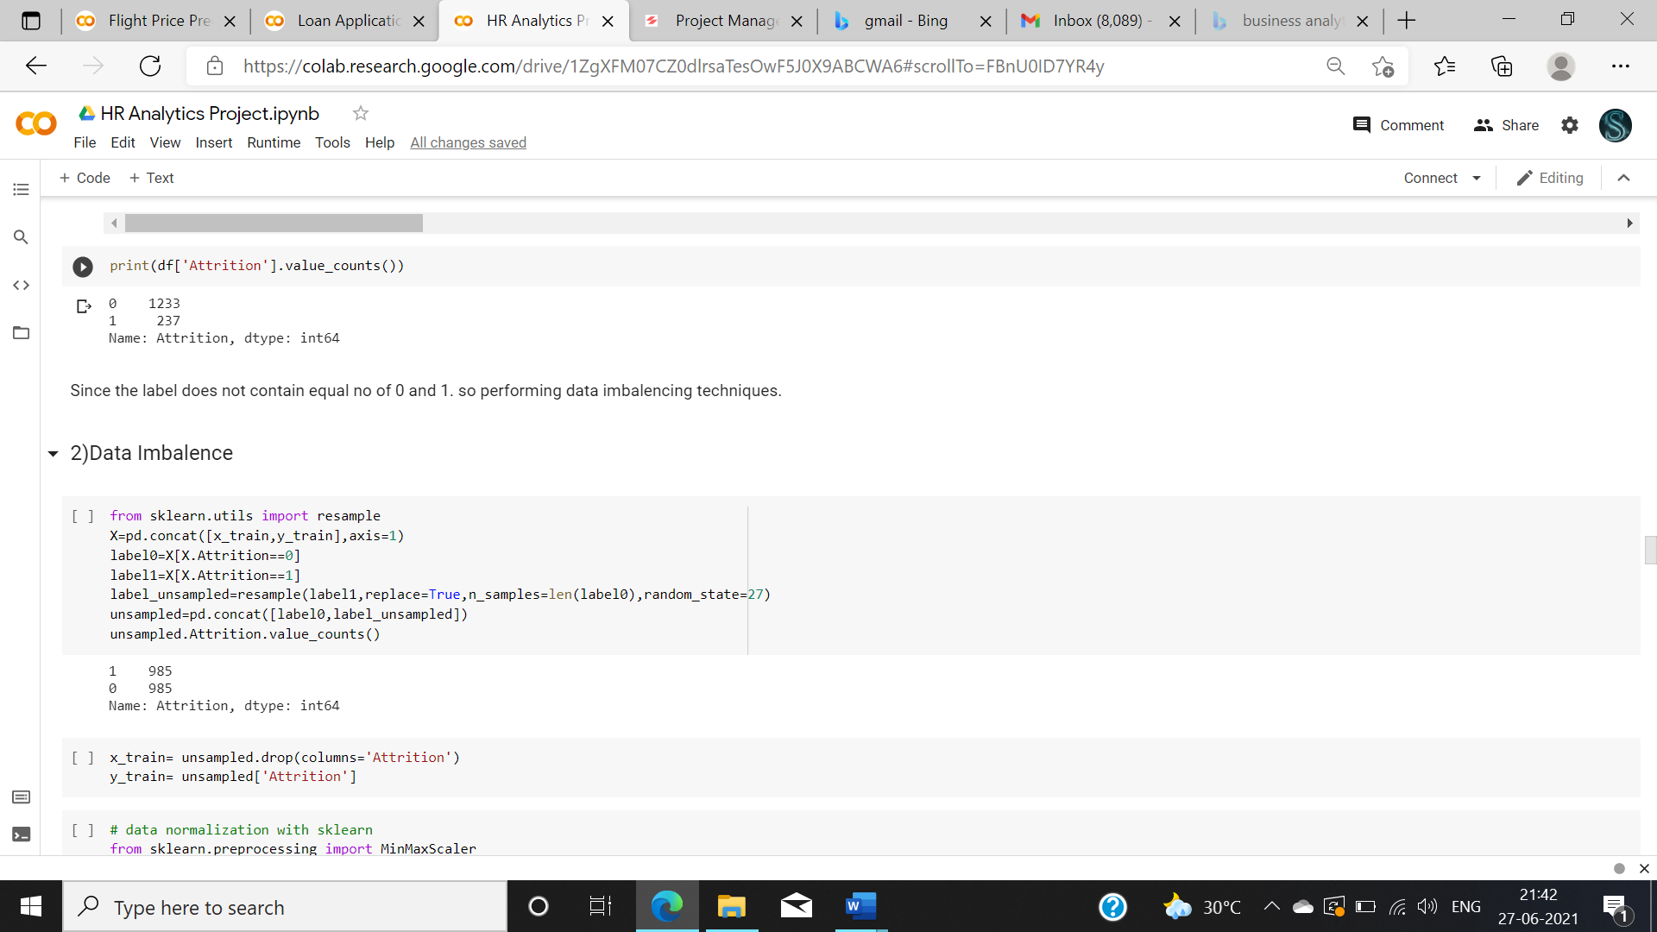

Fig 13 Data Imbalance

After encoding we need to perform scaling. Scaling needs to be done because attributes in our data might have a high range. we need to reduce that range in-order to perform efficient model. Here we used min max scaling we can also perform standard scaler to scale the data. After scaling your data will be converted into 0 to 1 format.

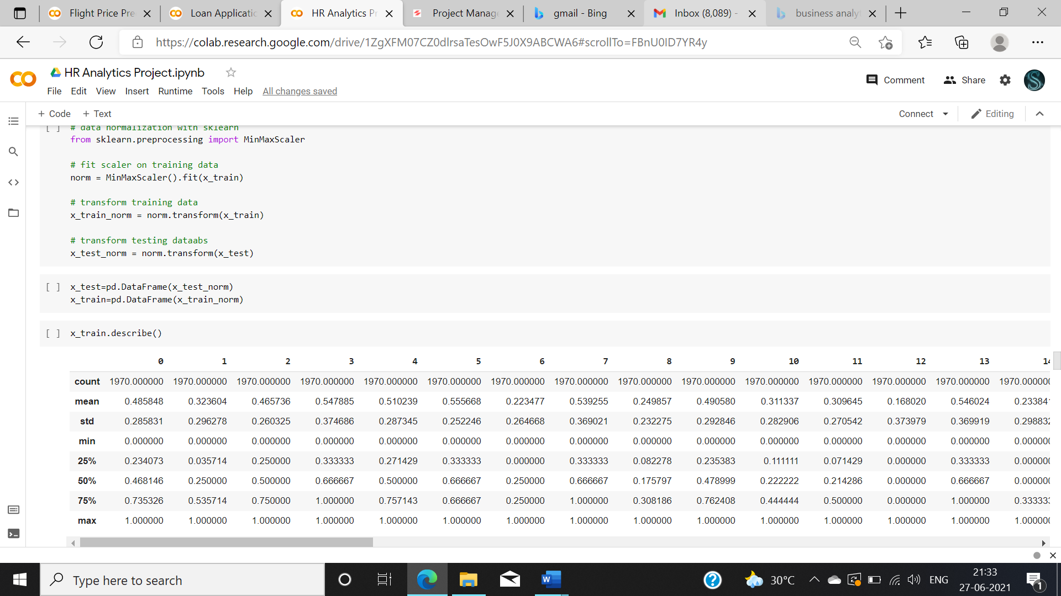

Fig 14: encoding

**Step 5- Building Machine Learning Models**

Now we have came to the most important and sensitive step of the whole analysis part which is constructing and finding best model for our data.

Now we need to construct various algorithms for this data set. Then using evaluation metrics, we need to finalize some best model for our problem. There are various algorithms available for classification problem we are going to see some of that.

We also need to find the cross-validation score to choose the best model

1. **Random Forest Classifier**

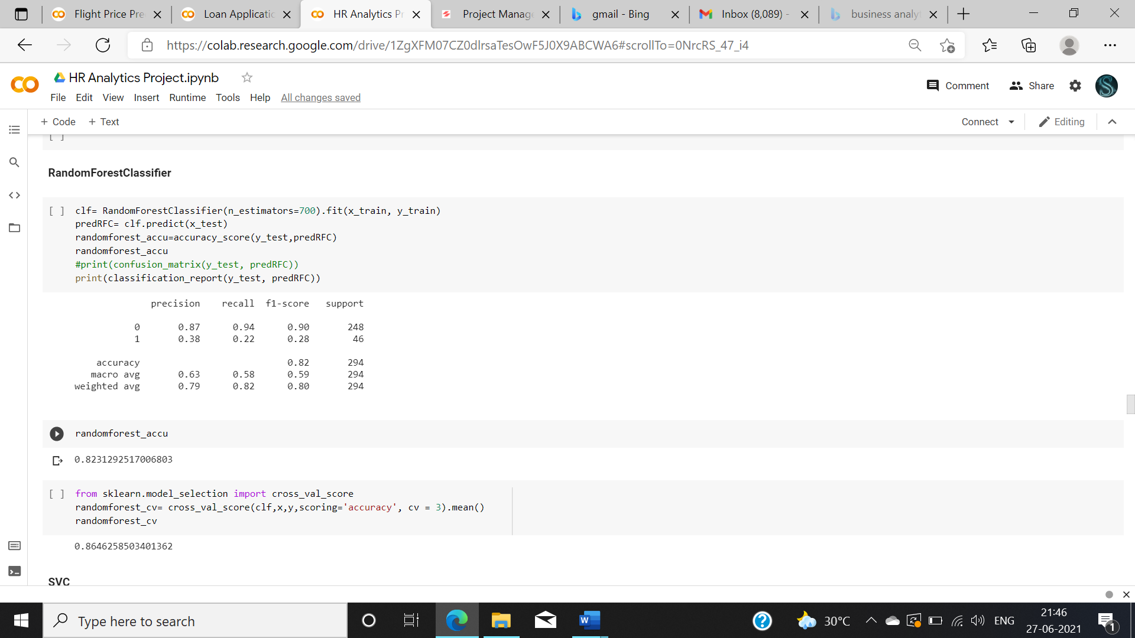

Fig 15: **Random Forest Classifier**

2. SVC

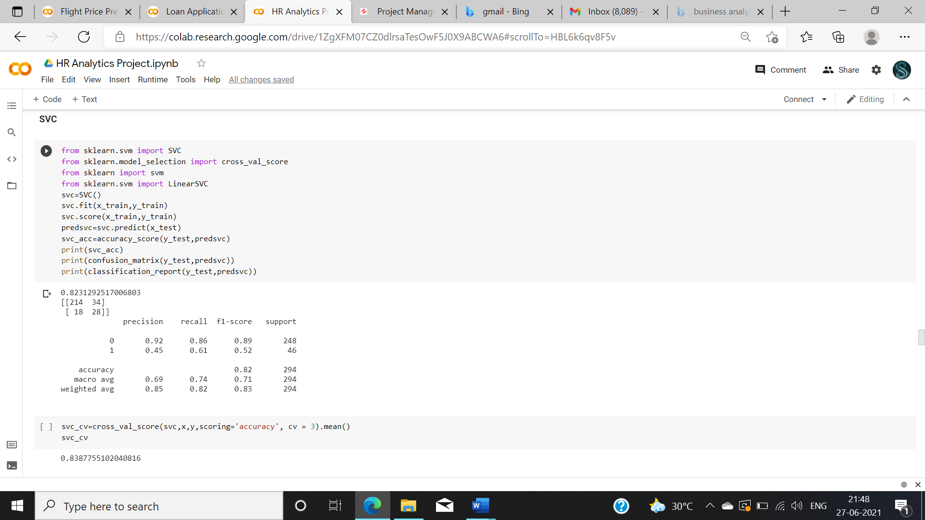

Fig 16: SVC

3. DECISION TREE CLASSIFIER

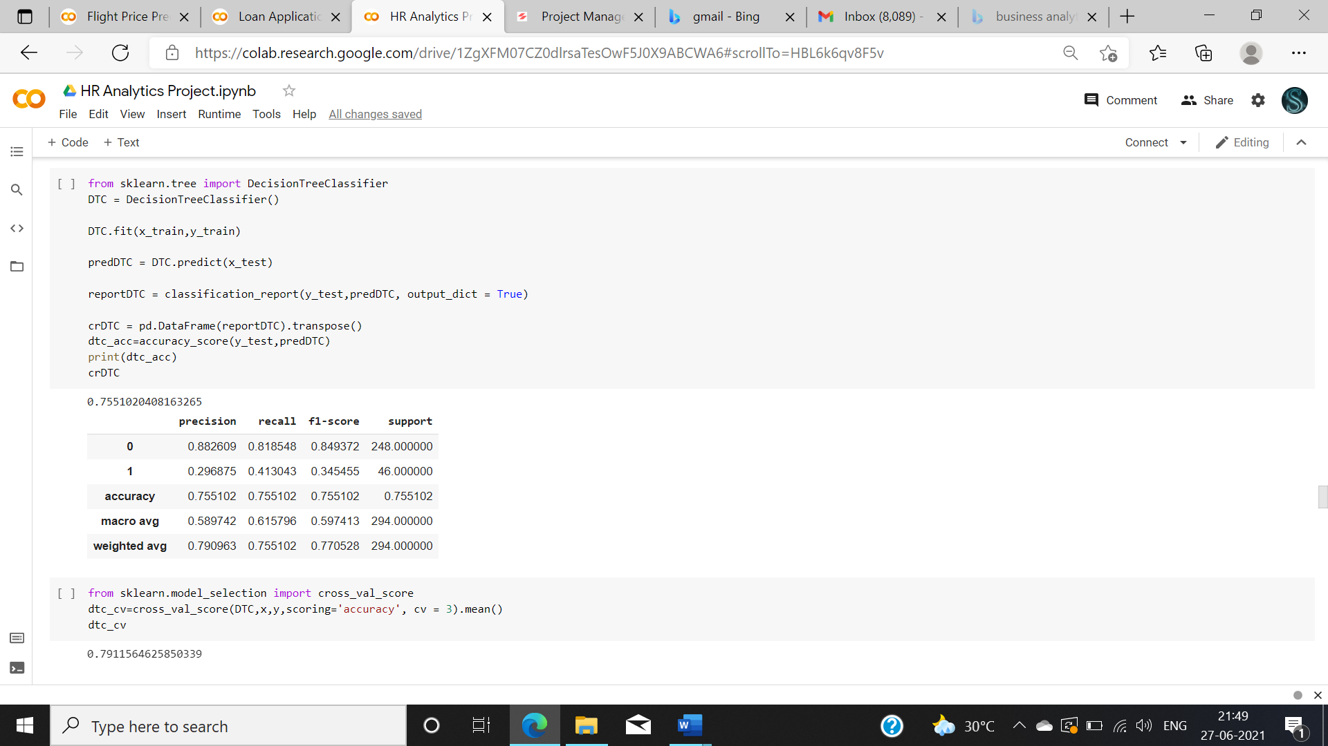

Fig 17: Decision tree classifier

4. **GaussianNB** 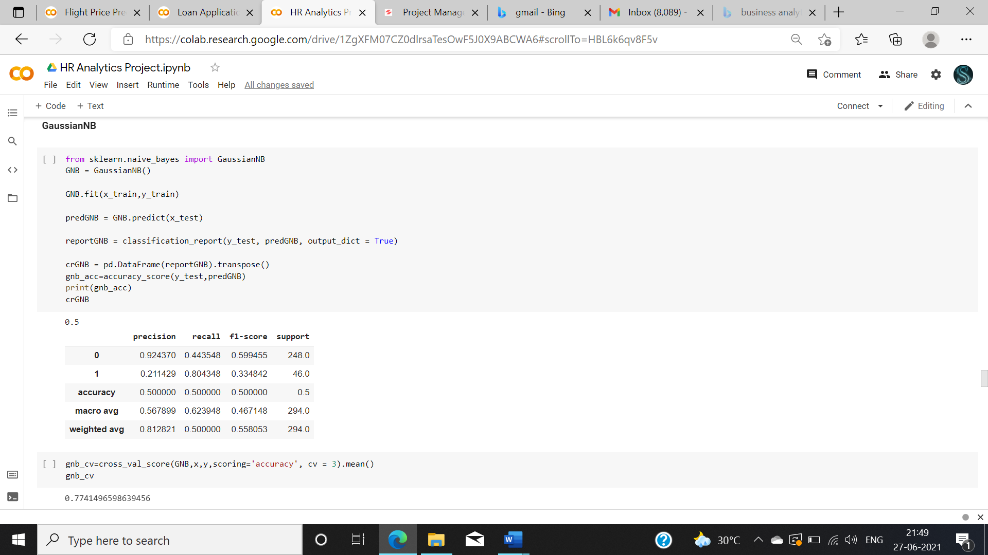

Fig 18: gaussian NB

5. KNN

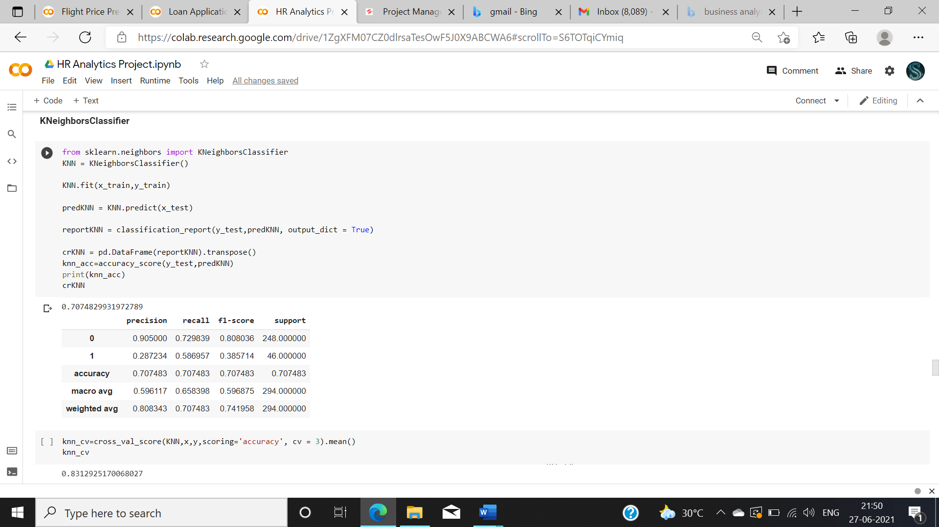

Fig 19 KNN

After constructing all the models, evaluation is done based on accuracy score and cv score

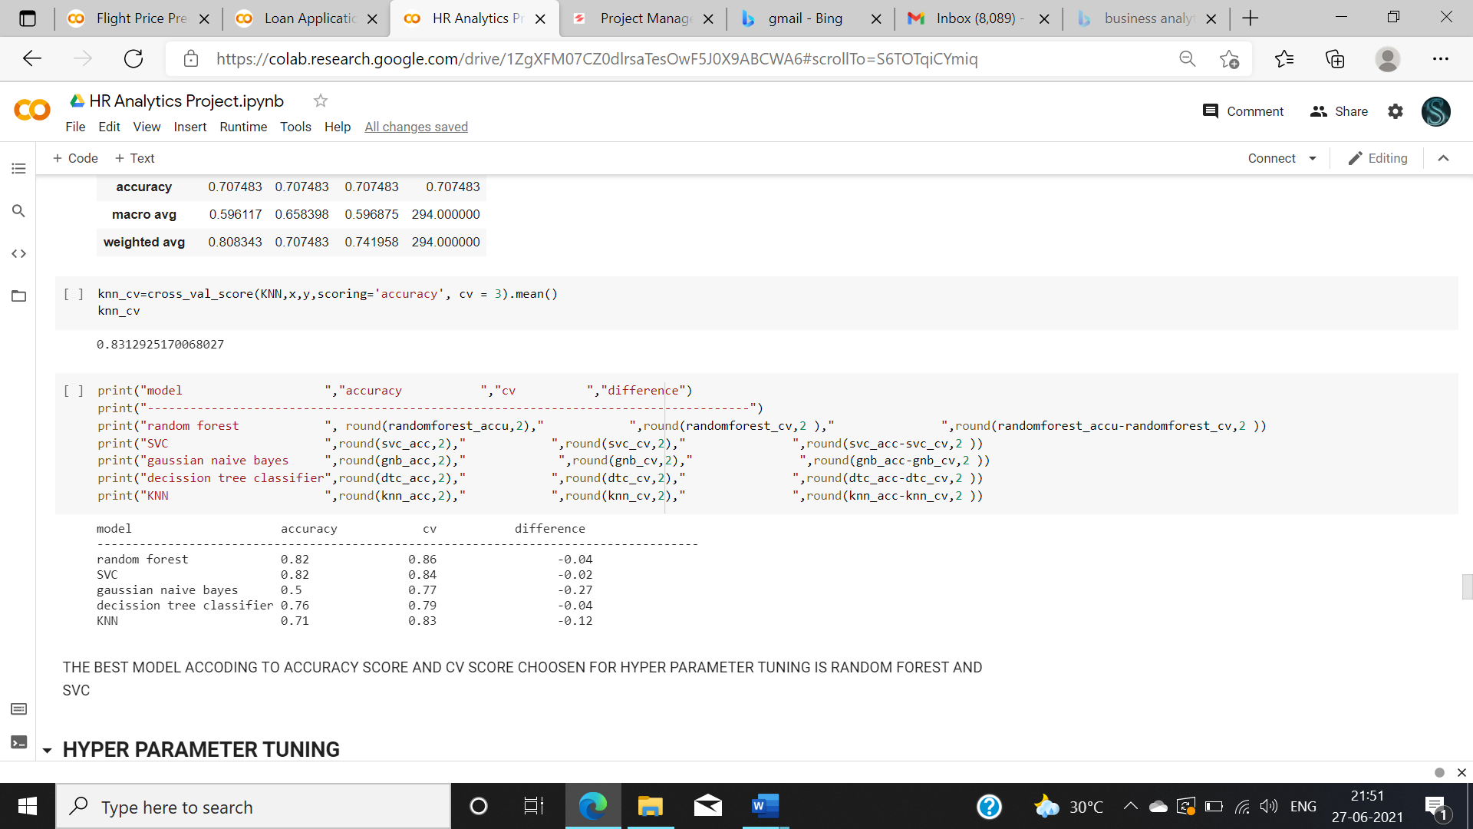

Fig 20 evaluating best model

the best model according to accuracy score and cv score chosen for hyper parameter tuning is random forest and svc so moving on with hyper parameter tuning with that model.

First before hyper parameter tuning the model we need to find the best random state. It helps in increasing the accuracy. Random state is the state where there is a least difference between test and train data score.

I have constructed a basic loop to find the best random state.

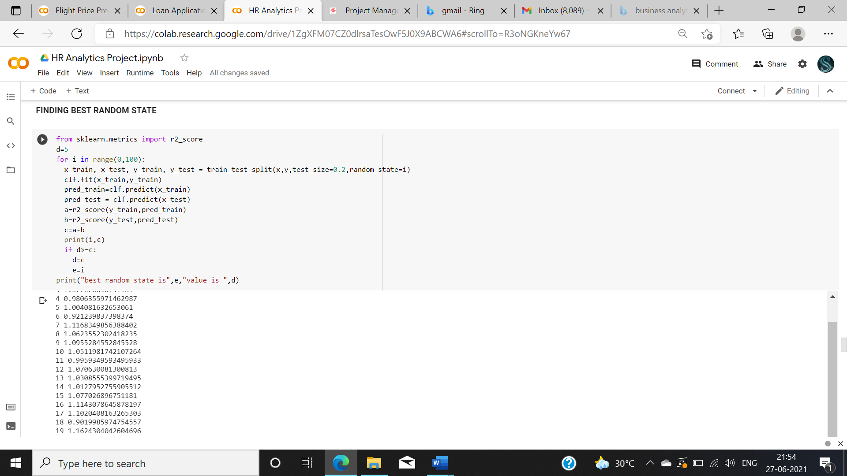

Fig 21: finding best random state.

After performing this model, we found the best random state is 84 in this case.

Hyper parameter tuning tends to increase the accuracy of the model. we are performing hyper parameter tuning for the best models.

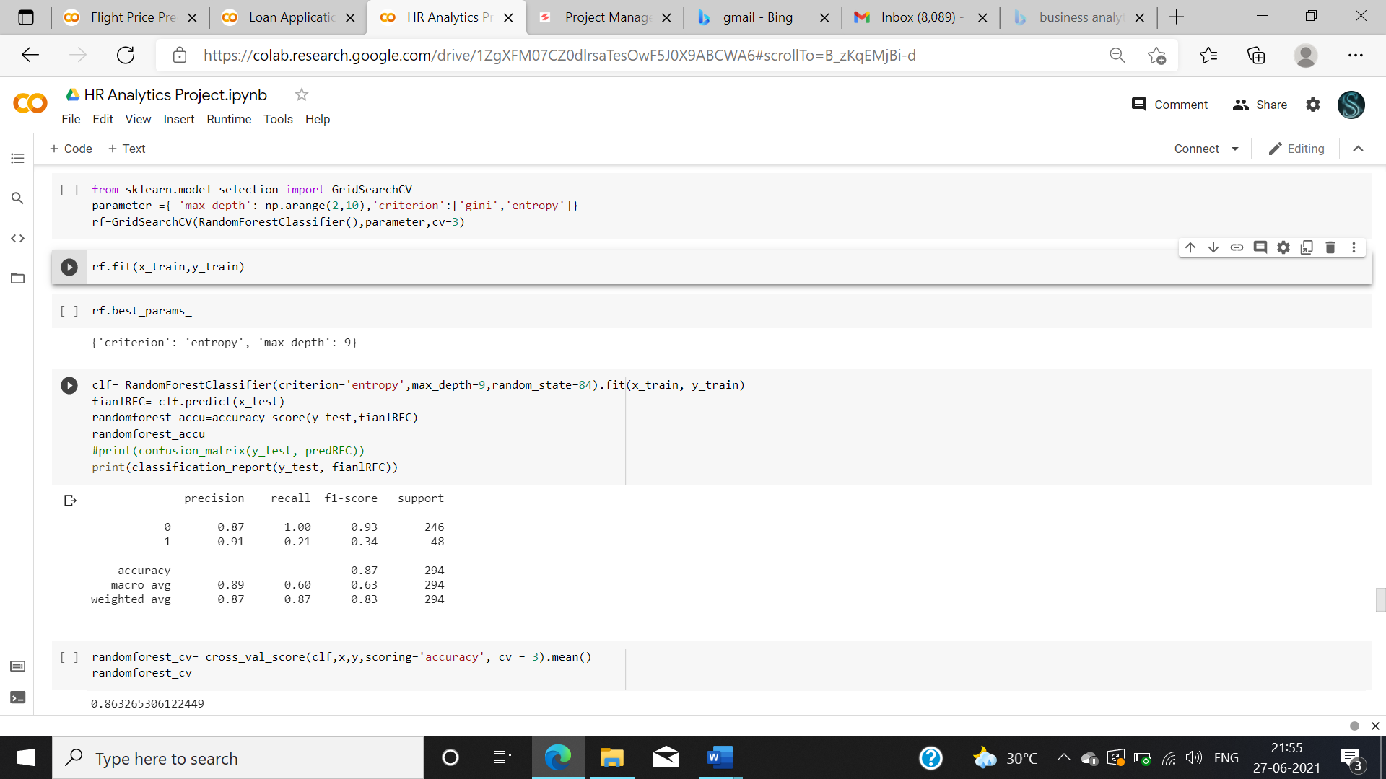

Fig 22 Hyper parameter tuning for Random forest.

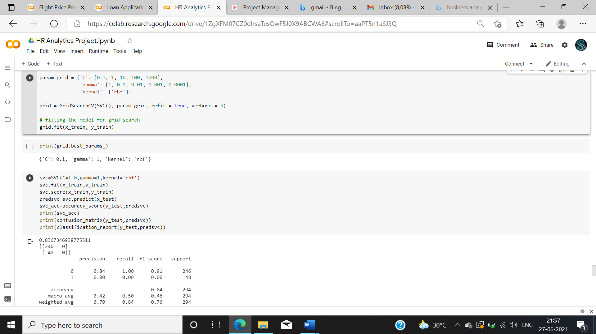

Fig 23 Hyper parameter tuning for svc.

**6.      CONCLUDING REMARKS**

Evaluating the constructed model

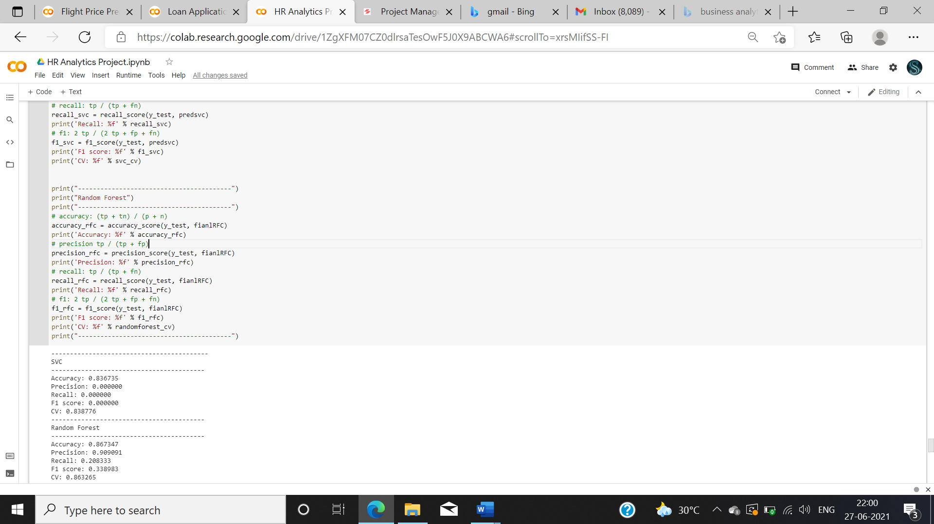

Fig 24: Evaluation metrics

There is another evaluation metrics called as AUC and ROC curve

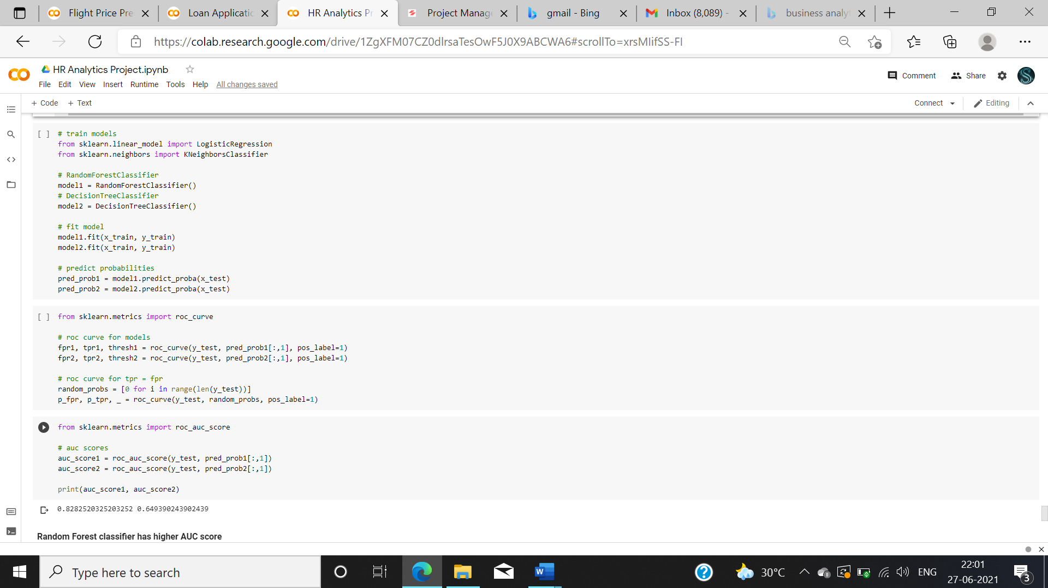

Fig 25 auc roc

Best model found after performing auc roc is “Random Forest classifier”

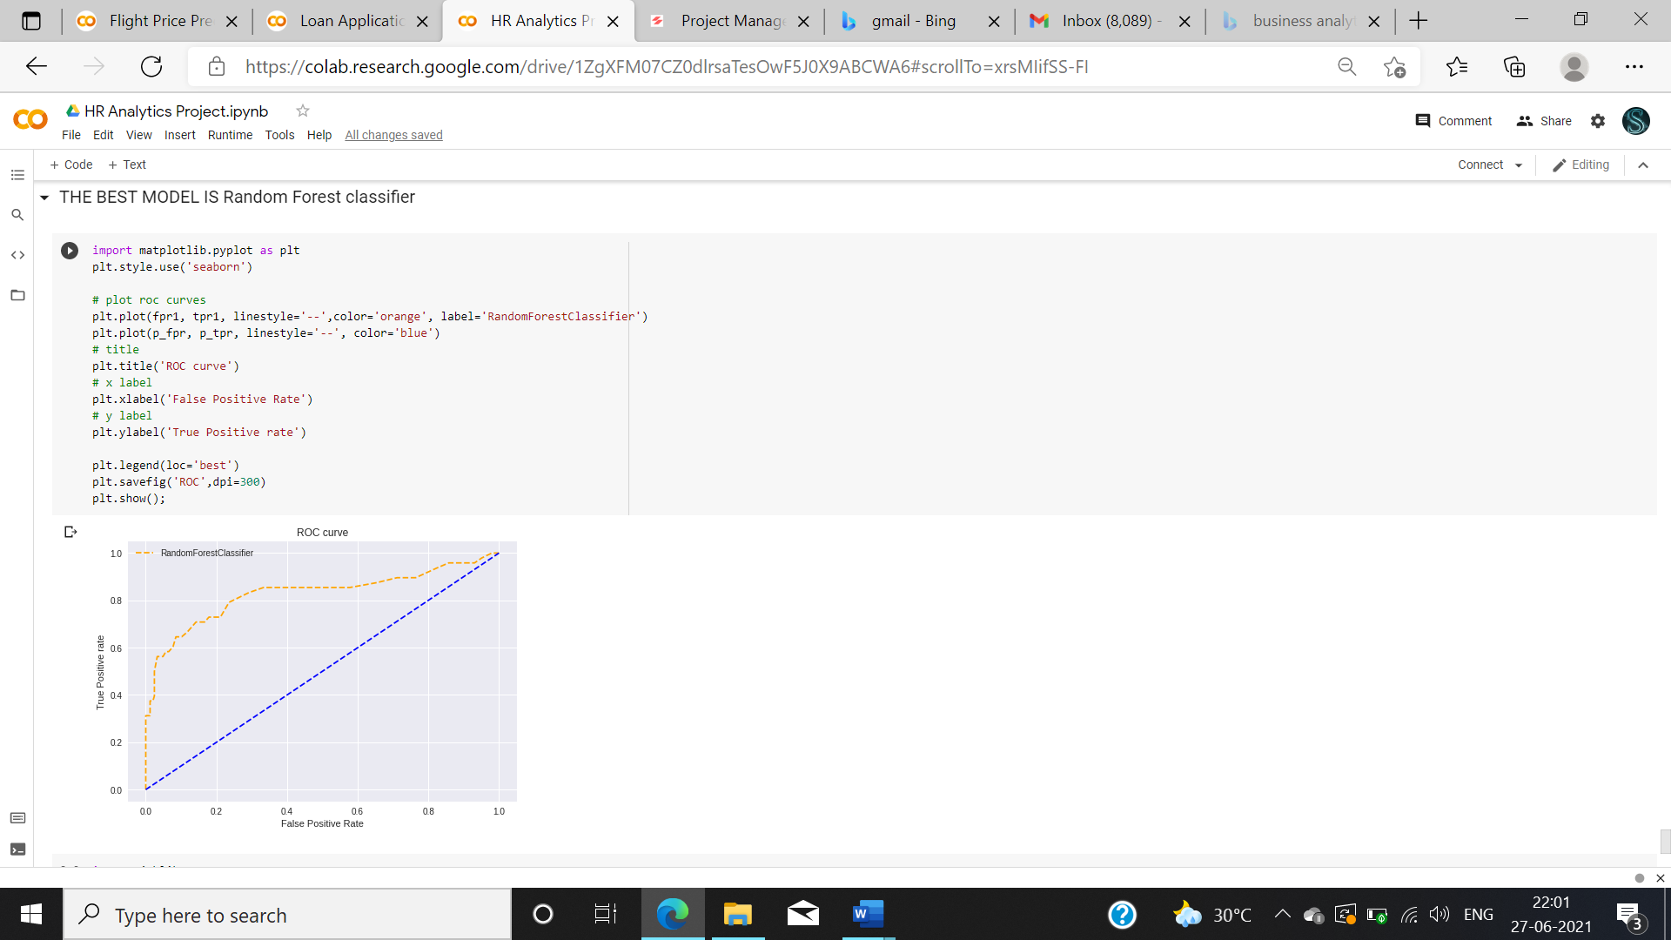

Fig 26: AUC ROC curve.

By the end of this project, we have predicted the candidates Attrition.

By performing this project, we got a good knowledge about how to perform an analysis and how important preprocessing a data. How to construct Machine learning models to predict the data. And how to choose the best model for specific data.

By performing uni-variant, bi-variant and multivariant analysis we can see the correlation between the data. We can make assumptions on the data and perform model.

Hope I gave a basic knowledge on solving a classification and regression problem.

**CONVERTING DATA INTO STORY.**

Last step of writing a data analysis project is about how to convert your data into story

Now in this modern era nobody is having time to spend a lot, so people are less attentive when you present your findings in old fashioned way. So there is need to present data/findings efficiently and effectively so that people no need to spend a lot of time in studding the work you have done.

There are few steps present in the story telling which is

**1. Structure your story in phases.**

Story should have a proper format and index as following

1. Exposition
2. Inciting Incident
3. Complication
4. Climax
5. Reversal
6. Resolution
7. Denouement

**2. Create context.**

Create a scenario and make them believe that they are one of the character in your story and tell them how important is to take the scenario. Ask them to imagine themselves in that story and make them understand the problem.so that it will be easer for them to understand your concept.

**3. Stick to a linear timeline.**

Though there have been some very well-narrated stories told through flashbacks or timelines that start between past, present, and future, the most frequently successful narratives are ones that are told in a clear beginning, middle, and end order. So always stick to the timeline and come back to where you started.

**4. Make it relatable by drawing on emotion.**

Create an emotion when you tell the story make them connect to the story. For example Give some example of a poor child try to express its need. And make them emotionally connect to the problem.

**5. Know your audience.**

Before getting your presentation started know about you audience because when you present your report to the people like 50-60 age needs to be treated differently when it comes to presentation. If you are presenting it to a collage student or a graduate, then it need to be like a different way of presentation. So always know your audience before telling your story.

Github link for the above two projects :

1.https://github.com/swathiramesh275/projects/blob/75f7564f0204c2338eb622c6013f1e0064383f7b/Flight_Price_Prediction%20final.ipynb

2.https://github.com/swathiramesh275/projects/blob/fe57538bc110705be4aa76cad84930fea37788ac/HR_Analytics_Project%20(1).ipynb

Hope this Blog is helpful for the Beginners of the data analysis.